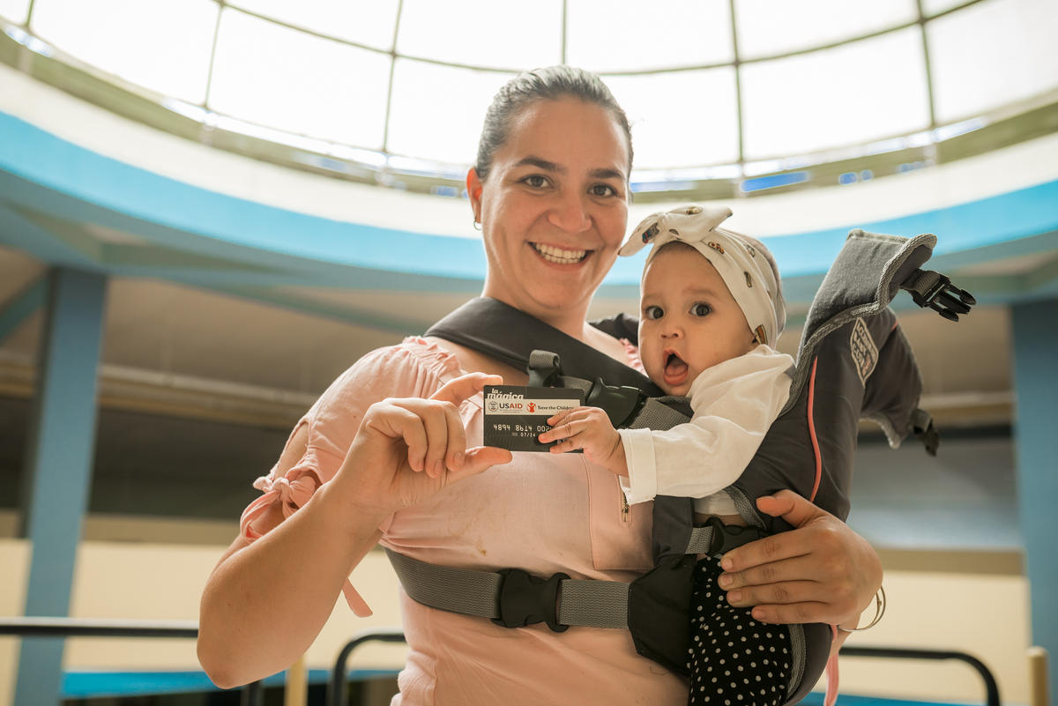

Bring

FINAL EVALUATION REPORT
multipurpose cash ‘plus’ assistance
to vulnerable venezuelans in peru
By Gabriela Carbajo & Alicia Matta

Table of Contents
LIST OF ACRONYMS 3
EXECUTIVE SUMMARY 5
1.1.1 Project Presentation 5
1.1.2 Key activities 5
1.1.3 Evaluation description 5
1.1.4 Key findings 6
1. BACKGROUND 9
1.1 Context 9
1.2 Description of the OFDA-FFP project 10
2. GROUNDS: SCOPE AND PURPOSE OF EVALUATION 12
2.1 Objectives 12
2.2 Conceptual framework 12
3. EVALUATION QUESTIONS 13
4. THEORY OF CHANGE 13
5. METHODOLOGY 14
5.1 Qualitative Component 15
5.2 Quantitative Component 16
6. FINDINGS 17
6.1 Key Indicators 17
6.2 Multipurpose Cash Transfers 20
6.3 Nutrition 42
6.4 Protection 49
6.5 Humanitarian Coordination and Information Management 54
7. CONCLUSIONS 55
7.1 Achievements and results: 55
7.2 Effectiveness and efficiency of interventions 56
7.3 Implementation of interventions 56
8. RECOMMENDATIONS 57
9. BEST PRACTICES 57
9.1 Cash Transfer Sector 57
9.2 Nutrition Sector 58
9.3 Protection Sector 58
9.4 Cooperation Sector 58
10. LESSONS LEARNED 58
11. BIBLIOGRAPHY 60
12. ANNEXES 62
Annex 1: Gender checklist 62
Annex 2: Minimum Standards for Child Protection in Humanitarian Action 63
Annex 3: Methodology for the Formulation of Lessons Learnt 64
Annex 4: Qualitative instruments 65
Annex 5: Testing of differences between databases and cohort 69

LIST OF ACRONYMS
UNHCR United Nations High Commissioner for Refugees
CEM Women's Emergency Centre
CFS Child-Friendly Spaces
DEMUNA Municipal Defense Centers for Children
DIRESA Regional Health Directorate
DRE Regional Education Directorate
EBF Exclusive Breastfeeding
FAO Food and Agriculture Organization
FCS Food Consumption Score
HHS Household Hunger Scale
IYCF Infant and Young Child Feeding
MIMP Ministry of Women and Vulnerable Populations
NFI Non-Food items
OECD Organization for Economic Co-operation and Development
IOM International Organization for Migration
UN United Nations
PAHO Pan American Health Organization
PNP Peruvian National Police
RCSI Reduced Coping Strategies Index
SC Save the Children
SRS Simple Random Sample
WASH Water, Sanitation and Hygiene

EXECUTIVE SUMMARY

Project Presentation
The Multi-Purpose Cash ‘Plus’ Assistance to Vulnerable Venezuelans, funded by USAID Office for Foreign Disaster Assistance (OFDA) and Office for Food for Peace (FFP), in Peru aimed at providing humanitarian assistance to vulnerable and at-risk Venezuelan migrant families. The specific goal was to cover beneficiaries’ basic needs and promote their inclusion into the local economy and society, while preventing development of negative coping strategies. This project had four main components: i) multipurpose cash transfers; ii) protection activities; iii) nutrition activities for infants and young children and iv) humanitarian coordination. The duration of the project was 12 months (from June 2019 to June 2020) and was implemented by Save the Children in five coastal regions of Peru: Piura, Lambayeque, La Libertad, Lima and Arequipa.

Key activities
The project consists of four components:
- Multipurpose Cash Transfers: Two packages were developed to target two groups of Venezuelan migrants, those in transit and those settling in Peru. The transit package aimed to cost of food, shelter, essential hygiene items, non-food items (NFIs), and transportation along the migration route in Peru; this package, primarily, served beneficiaries in two coast regions, Piura and Lambayeque. The settlement package covered a broader range of basic needs, such as food, shelter, essential hygiene items, household NFIs, transportation, communication (cellular data), and, in some cases, baby items for household with children under two years of age; this package was available to beneficiaries in all five regions (Piura, Lambayeque, La Libertad, Lima and Arequipa).
- Nutrition: This sector sought to improve the feeding practices of infants and young children from vulnerable Venezuelan and Peruvian populations.
- Protection: This sector aimed to promote the safety and well-being of Venezuelan children and women affected by the Venezuelan migration crisis in Peru, through child protection activities to prevent violence against children, and to provide socio-emotional support and build resilience to the migratory stress of children and adults.
- Humanitarian coordination and information management: This sector aimed to improve the unique system of databases on migrants and refugees prepared by humanitarian stakeholders, in a safe and coordinated manner.

Evaluation description
This report describes the results of the impact mixed methods, cross-sectoral final evaluation of the OFDA-FFP Multipurpose Cash ‘Plus’ activity. The quantitative component followed the same methodology as the baseline (systematic random sampling) to compare outcomes of endline to baseline. The subsequent qualitative component comprised 19 semi-structured in-depth interviews that further explored the quantitative findings, proposing causal factors; analyzed the achievements, effectiveness and efficiency of the interventions and the implementation processes; as well as the mainstreaming of the gender approach in the design, implementation and the outcomes of the project, from the perspective of the stakeholders.
The main research questions for the final analysis were:
  - Achievements and results:
    - To what extent did the implemented activities achieve the goals, objectives and indicators?
    - What were the main factors that influenced the achievement or not of the objectives?
    - Did the interventions reach target groups and individuals within the areas of intervention (groups in transit, settlement groups, pregnant and lactating women, older adults, people with disabilities, children participating in friendly spaces and children under 2 years)?
    - How did the project cooperate with other similar projects in the territory, at the national level, with other OFDA and FFP partners and with the State’s priorities?
    - What happened as a result of the project and the coordination between the different stakeholders involved in the humanitarian response?
  - Effectiveness and efficiency of interventions and their implementation:
    - What lessons were learnt in relation to the implementation, targeting and design of the program?
    - What were the good practices?
    - How efficient were project management, systems and processes established by the project?
    - How efficient has the use of financial resources been in obtaining the results?
    - How effective were strategies to improve gender equality at both the participant and project management levels?
    - How were protection issues addressed? How efficient and effective was it?
    - To what extent were local capacities strengthened?
    - Were there any unexpected effects/unforeseen changes?

Key findings
In terms of achievements and results, we observe that the results of the project have been mitigated by external factors.
Quantitative findings
At a quantitative level, food security indicators suggest that there has been no improvement in dietary diversity or frequency. For instance, at baseline, the proportion of beneficiary households (HHs) with an ‘acceptable’ food consumption score (FCS) was 65.3% and 65.8% at endline; similarly, only a slight improvement was observed at endline among HHs with ‘poor’ FCS – 8.5% compared to 10.3% at baseline. While nearly a two-thirds of the HHs had acceptable FCS both at baseline and endline, it is important to note that Peruvian diet is quite diverse as it is high in meat and fish, grains, legumes, and vegetables; HHs also have access to diverse foods given the urban context and access to supermarkets. 1/3 of HHs may have reported a poor or borderline FCS during evaluation due to COVID, given mandatory immobilization, loss of their income and decreased access to markets. Although, on average, HHs may have an ‘acceptable’ or adequate diet, HHs continued to resort to negative coping strategies indicating high food insecurity. At baseline, 40% of beneficiary HHs reported experiencing moderate of severe hunger, while at endline the proportion increased to nearly three-fourths (72%). The increase in the prevalence of HHs experiencing moderate or severe hunger could be attributed to the reduction of immediate income caused by the state of emergency and immobility in the country due to COVID-19, where households with children under five years of age were the most affected.
In contrast, on average, the proportion of children under six months who were exclusively breastfed and the proportion of children 6-23 months who received a minimum dietary diversity (i.e. consumed four or more foods groups) increased.
Other improvements observed include increased HH access to appropriate accommodations; non-food items such as bedding, cooking utensils; and clean water for drinking, cooking, and cleaning. In addition, a greater proportion of the beneficiaries reported feeling integrated into the Peruvian community and their treatment has improved.
Qualitative findings
At the qualitative level, beneficiaries, SC staff and interviewed partners recognize and value the vital usefulness of the project and the positive influence it has had on the well-being of beneficiaries. Cash transfers have allowed them access to basic items such as food, housing, medicines and hygiene products. Beneficiaries reported that cash transfers have allowed them access to basic items such as food, housing, and hygiene products. Nutrition activities have increased their knowledge of recommended breastfeeding and complementary feeding practices feeding among children aged 0-23 months, including increasing dietary diversity, and prevention and management of childhood anemia. Protection activities have raised awareness of domestic violence, particularly violence against children and adolescents, and gender-based violence (GBV); including children, on self-protection from risk situations. The project also informed about the reporting channels of violence situations, and strengthened socio-emotional well-being through workshops that helped build resilience. Cooperation activities and information system management made it possible to avoid duplication of access to the different projects, thus broadening the scope of humanitarian aid.
However, the impact of the project has been mitigated by external factors. Two main mitigating factors have been identified in achieving the objectives of the OFDA-FFP project. The first mitigating factor is the precarious means of support that ensure a process of stay with social and economic inclusion. The second mitigating factor identified was the COVID-19 health crisis, and the declaration of a state of emergency. This affected the access to employment and economic income of the beneficiaries; as well as the access to the benefits of the project. In some cases, health problems related to events that spread COVID-19, and there were difficulties in accessing medical care for those suffering from other health problems.
In regards to effectiveness and efficiency, on average, beneficiaries reported that both the cash transfers and complementary activities (IYCF and protection trainings and counselling) were timely and appropriate for their existing needs.
The project staff considered the project management to have been efficient, as it was coordinated at the regional and national levels. At the process level, various adaptations were made to the design of the components, using the different media, as well as redesigns to adapt to the routines and rhythms of the beneficiaries. At the systems level, the KOBO eligibility system allowed the identification of beneficiaries through an objective scoring system, while the use of the Migration Desk database managed by UNHCR allowed the extension of the scope of the different projects, avoiding the duplication of beneficiaries.
The use of financial resources was efficient, in particular by adapting to the central distribution day format which concentrated almost all the beneficiaries, and by adapting a telephone counselling device and a communication campaign via WhatsApp, within the framework of the intervention adapted to the restrictions of the confinement and health measures due to COVID-19.
Strategies to improve gender equality were also efficient. At the participant level, the emphasis on migrants in vulnerable situations, including women, was clearly presented. The activities were specifically designed considering the needs, and distribution of household roles, without being stereotyped (e.g. in the case of workshops aimed at the primary caregiver of children aged 0-2 years). At the project management level, staff and teams included both men and women, and in many cases where there was personnel rotation, the rotation was both men and women.
At the implementation level, changes in design were observed (mostly related to the health context), which reported good results. The profound changes in the context of intervention, the worsening vulnerability of the target population, and the restrictions on transit and contact imposed by health and security measures implied a series of unforeseen changes in the development of activities.
At the level of sustainability, we observe mitigated results. In some sectors such as health, sustainability was observed. In the case of work or housing, no clear or sustainable initiatives were recorded. In the protection and education sector, much variability was identified among local institutions, this probably associated with the absence of guidelines at the national, regional and local levels.
The OFDA-FFP project cooperated with several partners and allies in humanitarian assistance projects at the national, regional and local levels. This cooperation was carried out through coordination spaces, joint information systems, collaboration of thematic areas to share good practices, and articulated intervention with public institutions. Coordination between the different stakeholders involved in the humanitarian response has made it possible to intervene in an organized manner in the territory, with certain common standards and processes.
The report makes four main recommendations:
                - Extend humanitarian assistance to vulnerable Venezuelan migrants in the context of COVID-19, prioritizing access to housing and food, for a minimum period of three months.
                - Promote food security through the promotion of soup kitchens or food support networks.
                - To promote, through partners or allies, opportunities for entrepreneurship or self-employment for the heads of household.
                - Continue with the telephone counselling on nutrition and protection to guide, raise awareness and inform families about wellness issues and reliable reporting channels to deal with risk situations.
The evaluation report identified 14 'best practices’ in the four sectors of the project, including strategies for identification, registration, guidance and support during the paperwork, distributions of cash cards, workshops and talks, security standards for friendly spaces, telephone communication, and coordination with partners.
Regarding the lessons learnt, due to the nature of the project related to cash transfers for vulnerable migrant population, it is important to keep the actions within the target population. It is also important to address racism and discrimination against this vulnerable population, especially those that may occur in public institutions; since it is constantly reported these activities within this group of citizens Finally, it is important to guide public institutions to ensure coordinated work that facilitates long and complex inclusion processes.

1. BACKGROUND

1.1 Context
According to data from the United Nations Refugee Agency (UNHCR), more than 862,000 Venezuelans have arrived to Peru and more than 482,500 have applied for the refugee status. This makes Peru the first country to host Venezuelans in need of international protection and the second largest destination for Venezuelan refugees and migrants worldwide (UNHCR, 2020).
The report of the National Superintendency of Migration (2018) identified frequent problems of foreign migrants (mostly Venezuelan) in terms of vulnerability: the conditioning of the migratory situation of the foreign citizen to the will of the Peruvian spouse or the resident spouse, the undue application of the power to impose penalties and the violation of the family migratory unit (abusive spouses, who denounced women to the migratory authorities, thus sanctioning them with an order of compulsory exit with impediment of entrance and arbitrarily separating them from their children). The vulnerability of migrants is related to their illegal migration status, health problems, disability, pregnancy, poverty and human trafficking (National Superintendency of Migration, 2018a).
Regarding the sociodemographic characteristics of Venezuelan migrants in Peru, this is a predominantly young population (18-35 years), 58.3% are men, 86.7% entered by the Tumbes border checkpoint. In addition, the vast majority have carried out the temporary work permit, or asylum application, and 92.2% reside in Lima and Callao. 88% of Venezuelan migrants live in rented homes or rooms (National Superintendency of Migration, 2018b). Most of them are working age population and register a higher number of years of studies than the average Peruvian population. More than 65% of immigrants over the age of 14 send funds on a weekly or bi-weekly basis (BBVA Research, 2019).
With regard to the migratory conditions of Venezuelans who arrived to Peru, we can say that they leave Venezuela in a situation of greater vulnerability, both because of the worsening social, economic and political crisis, and because of the conditions of this population group, which did not have minimum basic services, mainly in health, to guarantee human well-being, especially for more sensitive groups. In addition, these are people trying to meet with an acquaintance or family member, who have left their country in an untimely way, without having information about the host country.
Regarding the employment situation, Venezuelans living in the city of Lima have joined the informal and precarious working environment, working as street vendors or sellers in commercial establishments. The Venezuelans who participated in this project also said they were discriminated by migration authorities and in their working environments. Blouin's report (coord) (2019) states that employment is riskier for women, including cases of human trafficking, forced labor and sex work:
With regard to access to work, it has been identified that the search for work is more dangerous for Venezuelan women, since they are victims of harassment or receive offers of jobs as hosts, waitresses, etc., but which would basically have a sexual connotation (Blouin, 2019: p.49).
In terms of health, 24% of Venezuelans declared they or one of their relatives got minor physical illnesses since their arrival to Peru. They also pointed out that migration has a strong psychosocial impact, due to the precarious conditions of Peru as a host country, and the precarious living conditions of the migrants’ relatives in Venezuela. As for housing, many migrants do not have access to housing, and live in precarious and overcrowded shelters being exposed to violence, and without state supervision (Blouin, 2019).
Between March and May 2020, the COVID-19 crisis and the extended state of emergency declared by the government of Peru have significantly affected the country’s most vulnerable households, including those of Venezuelan migrants. Many informal migrants have been unable to work, while others have lost their jobs. Venezuelan migrants did not have access to any bonus from the government of Peru, and only some families received donations (IOM, 2020). At the same time, the poorest districts are those associated with more COVID-19 cases. Some media report that the health, social and economic crisis has prompted several Venezuelans to return home because they have no means of support (BBC, 2020).

1.2 Description of the OFDA-FFP project
Objectives:
In 2018, given the migratory wave of Venezuelans in Peru and their precarious humanitarian situation, Save the Children implemented the OFDA-FFP, aimed to ensure living and food security conditions for vulnerable and migratory populations, and to reduce the use of negative coping strategies.
The project sought to provide emergency assistance to 32,989 vulnerable and at-risk Venezuelan migrants in Peru to cover their basic needs and promote their inclusion in the local economy and society, while preventing the development of negative coping strategies.
Sectors
The project consisted of four (4) sectors, detailed below.
- Sector 1. Multipurpose Cash Transfers
Multi-purpose cash transfers aimed to cover basic needs such as food, housing and utilities (water, electricity), household non-food items (NFIs), WASH NFIs, transportation, communications, and, in some cases, baby items for HHs with children under two years of age. The cash transfers were offered via two packages: the ‘Transit’ package and the ‘Settlement’ package.
The ‘transit’ package intended to cover expenses related to food, shelter/accommodations, WASH NFIs (hygiene items), transportation, and communications for migrants in route to their final destination. This “transit” cash assistance was one-off as it only aimed at covering the costs of beneficiaries’ travel and preventing them from remaining stuck in dangerous and precarious situations or cities where they were not planning to settle. The ‘Settlement’ package covered expenses related to food, shelter (including utilities), household NFIs, WASH NFIs, transportation, communications, and, in some cases, baby items for migrants looking to settle in Peru. Each household received three months of cash assistance as follows:
- Month 1: MPCA covering all food and non-food expenditures
- Month 2: MPCA covering all food and non-food expenditures, except the costs associated to sleeping and cooking kits
- Month 3: MPCA covering only costs associated with food
The length of assistance was determined considering the average amount of time required (at the time) to obtain the Peruvian’s temporary permit of stay (PTP), which notably enabled Venezuelans to access formal employment and associated benefits. Assessed Venezuelans also reported that it took them on average three months to secure stable income generation.
Save the Children also provided transit cash assistance in cities such as Piura, and collaborated with the delivery of information regarding temporary shelters and counselling, to help them reach their final destination quickly, safely and with dignity, without the need to resort to negative coping strategies such as living on the streets.

Figure 1. OFDA project sectors

Source: Author’s Elaboration.
- Sector 2. Nutrition
This sector aimed to improve the feeding practices of infants and young children aged 0-23 months from vulnerable Venezuelan and Peruvian populations. All beneficiaries of cash assistance were encouraged to participate in the nutrition activities throughout the life of the project. Participants received information via in-person sensitization sessions (prior to COVID-19) coupled with informational brochures; these sessions and materials covered recommended childhood nutritional practices, including proper preparation and use of locally available foods, safer hygiene and sanitation practices, early detection of acute malnutrition, and other information that could contribute to improving the nutritional status of migrants. Beneficiaries in the settlement group also benefitted from other IYCF workshops and breastfeeding counselling. SC trained community health agents to provide information to pregnant and lactating women (PLW), and caregivers of children under 24 months of age, on infant and young child feeding (IYCF), in briefings and workshops. These covered the following topics: of the importance of early and exclusive breastfeeding, how to address common breastfeeding challenges, and recommended complementary feeding practices. (Save the Children, 2019).
- Sector 3. Protection
This sector sought to promote the safety and socio-emotional well-being of Venezuelan children and women affected by the migration crisis in Peru, through various protection and psychosocial support activities. SC offered child-friendly spaces (CFS) during distribution days so parents who could not arrange child care could bring their children to the distribution point. SC also provided psychosocial workshops for Venezuelan children and adults in ‘settlement’ group, and trainings for volunteers and community members who SC had partnered with to deliver these services (Save the Children, 2019).
- Sector 4. Humanitarian Coordination and Information Management
This sector aimed to improve the overall coordination and information management among the implementing partners (IPs). The main focus was the unique system of databases on migrants and refugees prepared by humanitarian stakeholders, in a safe and coordinated manner. To achieve this, the project developed a coordination strategy with UN agencies, NGOs, local government institutions and public service providers, and capacity building of technical thematic working groups at local and national levels on assistance, data management, and knowledge sharing (Save the Children, 2019).

Implementation timeline
The project was implemented between June 2019 and June 2020 in Piura, Lambayeque, La Libertad, Lima, and Arequipa.

2. GROUNDS: SCOPE AND PURPOSE OF EVALUATION

2.1 Objectives
The overall objective of the final evaluation is to assess the outcomes of the OFDA-FFP project in relation to its goals, objectives, and key indicators.
The specific objectives are as follows:
- Evaluate project results in relation to goals, objectives, and key indicators.
- Assess how the activities affected certain target groups (transit versus settlement groups, pregnant and lactating women [PLW], older adults, people with disabilities and mothers and caregivers with children under 2 years old).
- Assess the effectiveness and importance of the method, transfers and complementary interventions to achieve the results of the activities.
- Identify best practices, lessons learned, strengths and challenges regarding the management, implementation and design of the activity and obtain recommendations that guide the improvement of intervention, giving specific indications that contribute to improving the design, management procedures, results and impacts.

2.2 Conceptual framework
  - Migrants and refugees
The International Organization for Migration (IOM) defines migration as the decision to migrate made by individuals and their families who move to another country or region to better their material or social conditions and improve the prospects for themselves or their family (IOM, 2006: p.41). IOM also defines refugees as persons that, owing to a well-founded fear of persecution for reasons of race, religion, nationality, membership of a particular social group or political opinions, are outside the country. (UN, 1951).
  - Migration and gender
Migration phenomena are affected by gender issues. Migration, far from being a homogeneous process, is constituted by a set of experiences, which in turn reproduce dynamics of inequality:
Gender affects the reasons for choosing to migrate, who migrates, the social networks migrants use to migrate, integration experiences and work opportunities at destination, as well as relations with the country of origin. The expectations, relationships and power dynamics associated with being male, female or child, and identifying yourself whether as lesbian, gay, bisexual, transgender or intersex, can have a significant impact on all aspects of this process. People who identify with one of the above categories also experience migration differently, with an inherent set of advantages and disadvantages (IOM, 2020).
Various studies have identified that migrant women may be exposed to a double vulnerability: one derived from gender and others derived from age factors (especially in the case of girls and adolescents), which in turn may be deteriorated by factors of discrimination, if they belong to ethnic minorities (Torrado, 2012; Palacios Valencia, 2016). The report of the UN Rapporteur on the Human Rights of Migrants (United Nations, 2019) identified among the causes for the migration of women and girls: high rates of sexual violence and gender discrimination, harmful practices such as child, early and forced marriage, violence and unequal access to rights and resources. Women, adolescents and girls are also particularly vulnerable during migration: they can be victims of violence, including gender-based violence, exploitation, trafficking, slavery and detention, during the journey or upon arrival, and by public officials, individuals or criminal gangs. The lack of adequate reception conditions in some countries has serious consequences for women's health, dignity and physical integrity. In destination countries, migrant women face multiple and intersectional forms of discrimination, not only as women and as migrants, but also on other grounds such as age, race and ethnicity, nationality, religion, marital and family status, sexual orientation and gender identity (United Nations, 2019. P.9).

3. EVALUATION QUESTIONS
The specific evaluation questions are as follows:
  - Achievements and results:
    - To what extent did the implemented activities achieve the goals, objectives and indicators?
    - What were the main factors that influenced the achievement or not of the objectives?
    - Did the interventions reach target groups and individuals within the areas of intervention (groups in transit, settlement groups, pregnant and lactating women, older adults, people with disabilities, children participating in friendly spaces and children under 2 years)?
    - How did the project cooperate with other similar projects in the territory, at the national level, with other OFDA and FFP partners and with the State’s priorities?
    - What happened as a result of the project and the coordination between the different stakeholders involved in the humanitarian response?
  - Effectiveness and efficiency of interventions and their implementation:
    - What lessons were learnt in relation to the implementation, targeting and design of the program?
    - What were the good practices?
    - How efficient were project management, systems and processes established by the project?
    - How efficient has the use of financial resources been in obtaining the results?
    - How effective were strategies to improve gender equality at both the participant and project management levels?
    - How were protection issues addressed? How efficient and effective was it?
    - To what extent were local capacities strengthened?
    - Were there any unexpected effects/unforeseen changes?

4. THEORY OF CHANGE
A relevant evaluation for interested parties should be based on a theory of change that maps the causal chain through inputs, outputs, outcomes and impacts, as well as the assumptions underlying the theory of change (White, 2009). Below, we describe the theory of change of the project Multipurpose Cash Assistance for Vulnerable Venezuelan Citizens in Peru:
- Inputs: Project inputs consist of all resources, including financial resources, personnel, information materials, information systems, children’s play materials, among others.
- Outputs: The OFDA project implemented 6 outputs: i. multipurpose cash transfers for groups in transit and settlement groups; ii. Promotion, counseling, and support of recommended IYCF practices; iii. Child-friendly places; iv. Psychosocial support; v. training in partner protection; vi. Unique database system.
- Outcomes: The project established 4 expected outcomes: a. vulnerable migrants at risk meet their basic needs; b. vulnerable migrants at risk improve infant and young child feeding practices; c. children, adolescents and women are protected and safe; d. humanitarian action is coordinated.
- Impact: The goal of the project is the following: vulnerable and at-risk migrants of Venezuelan nationality in Peru are integrated into the local economy and society, and avoid negative coping strategies. 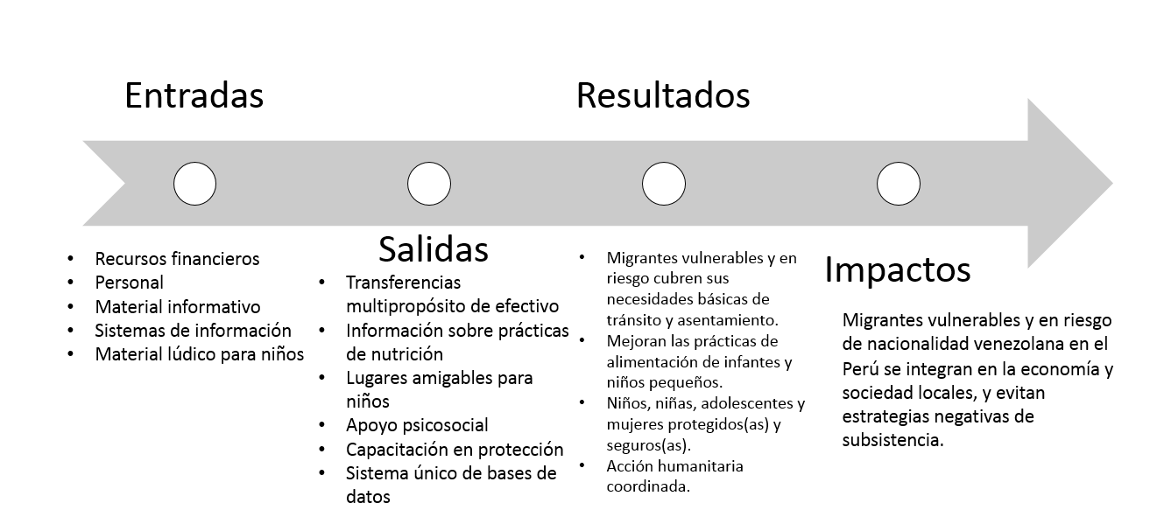

5. METHODOLOGY
SC employed a mixed-methods, participant-based evaluation and used a systematic random sampling methodology for the quantitative endline.
The consultancy was designed and implemented according to the specific characteristics of the Evaluation of Humanitarian Assistance (EHA):
  - Restricted access: Talking to affected populations can be challenging, limited, or impossible. The evaluator may not be able to visit projects or programs, thus most of the evaluation would be done remotely.
  - Lack of data: Data may have been destroyed or found irrelevant due to conflict or population movements. Baseline data may be difficult to obtain, particularly in more protracted crises.
  - Quick and chaotic responses: Projects or programs may not have clear project plans or Theories of Change. The work was planned quickly and needed to evolve to adapt to changes in the crisis.
  - High staff rotation: Humanitarian projects have tended to be shorter compared to projects in other sectors, such as international development. Staff may not stay long within a response. Finding key informants can be a challenge for evaluators.
  - Data protection and ethical considerations: It is difficult to design data collection and management tools that meet the ethical and analytical challenges posed by the principles of "no harm" and protection risk reduction (Better Evaluation, 2020).
The Humanitarian Aid Department of the European Commission also identifies important differences between ‘regular’ evaluations and those carried out in the context of a humanitarian situation. Humanitarian programs often operate under considerable time pressure and in a very fluid and changing context, with lack of security, absence of authorities, and difficulties of access, disruption of infrastructure and services, massive displacement and human rights violations. Besides, humanitarian interventions are severely limited in terms of human and budgetary resources (European Commission Humanitarian Aid, 2007).
The evaluation will be conducted under Save the Children's guidelines and policies on safeguarding children, ethical standards, confidentiality and protection of information from informants.

5.1 Qualitative Component
The qualitative component aimed to evaluate the project from the conceptions, experiences, and assessments of the beneficiaries and the members of the implementation team. The qualitative component of the evaluation analyzed the following dimensions:
- Project achievements and results: Results represent the benefits that a project or intervention can offer.
- The effectiveness of project management, i.e. the extent to which an activity achieves its objectives (OECD, s/f).
- The established systems and processes.
- Strategies to improve gender equality (at participant and project management level), based on the gender analysis checklist proposed by OECD DAC (see Annex 1).
- Protection of children and adolescents, based on the minimum standards for the protection of children and adolescents in humanitarian action established by the UN Refugee Agency (see Annex 2).
- Exit strategies and their implementation: Outputs are the tangible and intangible products resulting from project activities. To evaluate project outputs, the evaluation will seek to answer the following questions: Have the quantity and quality of the outputs/products produced so far been satisfactory? Are the benefits of the outputs/products the same for men and women? Are the outputs/products being used by the project beneficiaries? Have the outputs/products been transformed by the project beneficiaries into results? How do the outputs/products contribute to the organization's objectives? How do they contribute to gender equality? (OIT, s/f).
- Performance monitoring: This is the process in which the supervisor ensures that the employee is making progress towards the established goals and objectives.
- Conflict sensitivity: in humanitarian crises, divergent views and problematic situations often arise that stir up emotions and may lead to an escalation of the conflict. Therefore, humanitarian assistance teams must ensure powers of self-awareness, assertive communication and negotiating skills to avoid the escalation of conflicts.
- Lessons learnt: Lessons learnt can be defined as knowledge acquired about a process or about one or more experiences, through reflection and critical analysis of the factors that may have affected it positively or negatively. Following the recommendations of the Inter-American Development Bank, lessons learnt capture evidence and identify cause-effect relationships and trends, tailored to a specific context, and suggest practical and useful recommendations for the application or replication of new knowledge in other contexts and in the design and/or implementation of other projects or initiatives that aim to achieve similar results. In order to raise the lessons learnt, a Knowledge Note will be incorporated into the report, in the form of a short document (no more than 3 thousand words) structured in the following sections: (i) background, (ii) description of lessons learnt and recommendations, and (iii) references. For the formulation of the lessons learnt, we will use the methodology recommended by the IDB (see Annex 3).
- Documenting good practices: A good practice is a process or methodology that is ethical, fair and replicable, and has been shown to be effective in achieving its objectives, and can therefore be recommended as a model. To identify and document good practices, we will follow the recommendations of the Food and Agriculture Organization of the United Nations (FAO, 2015).
- Analyze the impact of the COVID-19 crisis on the beneficiaries and the strategy.
The following qualitative instruments were designed and implemented to collect the evaluation information.
Table 1 Qualitative instruments
Nº | Instrument | Applications | Total applications
1 | Question guide for in-depth interviews with adult male beneficiaries. | 2 interviews in Lima and 2 in La Libertad | 4
2 | Question guide for in-depth interviews with adult female beneficiaries. | 2 interviews in Lima and 3 in La Libertad | 5
3 | Question guide for in-depth interviews with the Project personnel. | Staff from the different areas and regions (Lima, Piura, Lambayeque, La Libertad and Arequipa) | 9
4 | Question guide for in-depth interviews with partners. | 1 group interview with two partners | 1
 | TOTAL APPLICATIONS |  | 19
Participants from the following groups were considered for KIIs:
- Pregnant women or families with children under 2 years of age.
- Families with people with disabilities or chronic diseases.
- Families with older adults
A semi-structured in-depth interview guide was developed and used for remote, phone-based interviews. The analysis consisted mainly of dumping data into an analysis matrix (memos, quotations, and code counting).

5.2 Quantitative Component
The team adapted the standard questionnaire used at baseline – updated to reflect endline-only indicators - and administered via Kobo Toolbox/Kobo Collect mobile application, keeping in line with the baseline process. The evaluation was designed to detect statistically significant changes in estimates from baseline to endline for the key indicators defined by the project, including:
Key Project Indicators
n | Key Indicator | Definition
1 | The Food Consumption Score (FCS) | Percentage of families with a poor, borderline, and acceptable food consumption score. FCS is a composite score based on dietary diversity, food frequency, and the relative nutritional importance of different food groups.
2 | Reduced Coping Strategies Index | Required: Average, standard deviation, confidence interval (95%) and mean.
3 | Household Hunger Scale (HHS): | Prevalence of households with moderate or severe hunger.
4 | Exclusive breastfeeding (EBF) | Proportion of infants 0-5 months of age who are fed exclusively with breast milk.
5 | Minimum Dietary Diversity - Children | Proportion of children 6–23 months of age who received food from 4 or more food groups in the 24 hours prior to the survey.

5.2.1 Sampling Methodology
All participating HHs were registered using a standardized registration form, which was administered via Kobo Toolbox software. The participant registration was used to develop a sampling frame for the evaluation, which included:
- Unique family identification number.
- Family contact information (including name, address, primary phone number, and secondary phone number [if any]).
- The characteristics of the family (size and gender composition of the family).
As this data was included in the baseline sampling frame, such information was not collected again in the final (endline) survey. The quantitative portion of the final evaluation used a participant-based systematic one-stage random sampling methodology.
Systematic one-stage random sampling (SRS) and sample size.
The evaluation team used the participant-based one-stage SRS design as this is the same methodology that was used for the baseline survey. A one-stage SRS design is favorable, as it is an equal probability selection method and the information is self-weighted, which is necessary to produce unbiased estimates. Also, the collection of information in an SRS is simpler in terms of execution and the resulting data is easier to analyze, which decreases the probability of analytical or process errors.
At the beginning, the evaluation team planned to use the same set of baseline beneficiaries (1,234 families), in line with a panel design, for the final evaluation. However, the transient nature of the target population, the additional challenges of the collection method (over the phone) and the national state of emergency implied that the full sample would be difficult to reach. The evaluation team was able to interview 638 families of the same baseline participants; although this is about half of the baseline sample (1,234), it exceeds the minimum FFP sample size requirement for SRS of 339, and is, therefore, representative of the target beneficiary population.

6. FINDINGS

6.1 Key Indicators
Indicator estimate report of Key Project Indicators
Indicator | Report level | Baseline (LB) |  |  |  | Endline
 |  | n | Value LB | Mean LB | Confidence Interval  (95%) | n | Evaluation value | Mean Evaluation | Confidence Interval | Welsh test (95%)  Diff. Avg.
Food Consumption Score  (FCS) | Nationally | 1234 | 44.12  (18.54) | 50,00 | $${}_{-}^{+}{1.03}$$ | 638 | 44.52  (17.78) | 43 | $${}_{-}^{+}{1.38}$$ | 0.40
 | Gender
 | Male | 128 | 40.88  (19.17) | 38,5 | $${}_{-}^{+}{3.32}$$ | 52 | 42.34  (16.31) | 41.25 | $${}_{-}^{+}{4.43}$$
 | Female | 1106 | 44.50  (18.44) | 43,25 | $${}_{-}^{+}{1.08}$$ | 586 | 44.71  (17.90) | 43.75 | $${}_{-}^{+}{1.45}$$
 | Region
 | Arequipa | 65 | 55.75  (17.29) | 53 | $${}_{-}^{+}{4.20}$$ | 24 | 55.63  (14.04) | 56.5 | $${}_{-}^{+}{5.62}$$
 | La Libertad | 262 | 42.97  (17.16) | 41.75 | $${}_{-}^{+}{2.08}$$ | 154 | 43.51  (17.99) | 40.25 | $${}_{-}^{+}{2.84}$$
 | Lambayeque | 229 | 44.59  (20.62) | 42 | $${}_{-}^{+}{2.68}$$ | 229 | 33.19  (18.74) | 35 | $${}_{-}^{+}{1.98}$$
 | Lima | 464 | 41.65  (16.84) | 41 | $${}_{-}^{+}{1.53}$$ | 277 | 39.40  (15.33) | 37.5 | $${}_{-}^{+}{1.81}$$
 | Piura | 214 | 46.85  (20.09) | 47.25 | $${}_{-}^{+}{2.69}$$ | 94 | 55.56  (17.75) | 53.75 | $${}_{-}^{+}{3.59}$$
Reduced Coping Strategies Index  rCSI | Nationally | 1234 | 30.44  (12.99) | 29.5 | $${}_{-}^{+}{0.73}$$ | 638 | 35.02  (11.59) | 36 | $${}_{-}^{+}{0.90}$$ | 4.57  ***
Household Hunger Scale  HHS | Nationally | 1234 | 1.96  (1.54) | 2 | $${}_{-}^{+}{0.08}$$ | 638 | 2.26  (1.37) | 2 | $${}_{-}^{+}{0.11}$$ | 0.29  ***
Exclusive Breastfeeding (EBF) | Nationally | 119 | 34% |  |  | 27 | 44%
 | Gender
 | Male | 62 | 32% |  |  | 10 | 60%
 | Female | 57 | 35% |  |  | 17 | 35%
Minimum Dietary Diversity - Children  (MDD-C) | Nationally | 262 | 70% |  |  | 227 | 100%
 | Gender
 | Male | 141 | 71% |  |  | 134 | 100%
 | Female | 121 | 69% |  |  | 93 | 100%
***significance at 95%

6.2 Multipurpose Cash Transfers
Indicator 1: | Total number of people assisted through multipurpose cash activities
The activity reached 32,989 individuals with MPC transfers. The transfers were aimed at helping vulnerable and at-risk migrants of Venezuelan nationality in Peru meet their basic needs and promote their inclusion in the local economy and society while mitigating the use of negative coping strategies.
Indicator 2: | Percent of beneficiary households reporting adequate access to non-food items
A little over half (51%) of beneficiary HHs reported adequate access to non-food items, such as bedding, clothing, kitchen items among others; this indicates a significant increase from baseline (16%).

Figure 1. Percentage of households with adequate access to non-food items
The proportion of households with children under the age of two years with adequate non-food items such as ovens, kitchenware and bedding has increased significantly – from 35% at baseline to 58% at endline.

Figure 2. Percentage of households without and with children with adequate access to non-food items
Indicator 3: | Percent of households with "acceptable" food consumption score (FCS)
Indicator 4: | Percent of households with "borderline" food consumption score (FCS)
Indicator 5: | Percent of households with "poor” food consumption score (FCS)
At endline, 65.8% of beneficiary HHs had an "acceptable" food consumption score (FCS), 25.7% had "borderline" FCS, and 8.5% had “poor” FCS. No significant improvement is observed from baseline, where the percentage of HHs with “acceptable” FCS was 65.3% and those with “poor” FCS was 10.4%.

Figure 3. Percent of households with 'acceptable', 'borderline', and 'poor' food consumption score at baseline and endline
Nearly two-thirds of HHs had an acceptable FCS both at baseline and endline, as this indicator did not change between the two surveys (65.3% at baseline vs 65.8% at endline). Although, on average, HHs may have an ‘acceptable’ or adequate diet, HHs continued to face food insecurity, which is confirmed by the mean difference test in Table 3. Another factor that may have contributed to the lack of improvement in the dietary diversity of beneficiaries at endline could be the economic downturn and decreased access to markets due to COVID-19. Approximately, 87% of beneficiaries reported that the spread of COVID-19 and governmental lockdown/quarantine caused them to use certain food-based coping strategies more frequently.
However, when baseline and endline results are compared to post-distribution monitoring (PDM) results (only as a reference point, not comparatively), a majority of the HHs (93%) had an “acceptable” FCS, reflecting immediate effects of cash assistance.

Figure 4. Percent of households with 'acceptable', 'borderline', and 'poor' FCS at baseline, PDM, and endline
Additionally, findings suggests that households without children under 2 years old had a better dietary diversity than households with children. For instance, households without children saw an improvement from baseline to endline – 62.5% to 66.2% - while those with children, saw a slight decrease – from 68.9% to 65.4%.

Figure 5. Percent of households with and without children under two years of age with 'acceptable', 'borderline', and 'poor' FCS
Indicator 6: | Percent of beneficiary households reporting having adequate access to water, as defined by Sphere or national standards
Evaluation findings show that two-thirds (69%) of the beneficiary households reported having adequate access to water, according to national standards, indicating an increase of four (4) percentage points from baseline.
Having access to safe water for cooking and drinking reduces the risk of diseases that can occur predominantly among the most vulnerable groups such as children, pregnant and lactating women, or the elderly.

Figure 6. Percentage of households with adequate access to water at baseline and endline
The increase in access to safe water for drinking and cooking occurred, to a greater extent, in households in the group in transit, where the proportion of households with access to it increased by about seven (7) percentage points.

Figure 7. Percentage of households in group in transit and settlement groups with adequate access to water
Indicator 7: | Percentage of beneficiary households reporting adequate access to essential WASH non-food items (NFIs), as defined by Sphere or national standards.
At endline, more than half of the beneficiary HHs (58%) reported adequate access to essential WASH NFIs such as toiletries, sanitary pads, etc., indicating no improvement from baseline (59%). The lack of improvement may be related to the fact that the money intended for these types of goods were used on food products, due to the adverse context of the economy resulting from the COVID-19 mobility restrictions. At lower levels of disposable income, the proportion of spending on food items is higher.

Interestingly, findings show a slight decrease in ‘settlement’ group’s access to WASH NFIs – from 63% at baseline to 69% at endline – compared to HHs in transit, who show an increase of about four (4) percentage points (from 42% to 46%). This may be because households in transit were people travelling alone and households in settlement are composed of large families with children, giving priority to purchasing of food items.

Figure 8. Percentage of groups in transit and settlement groups with adequate access to WASH NFIs at baseline and endline
Indicator 8: | Percentage of beneficiary households whose shelter solutions meet agreed technical and performance standards
Evaluation findings show that about two-thirds of beneficiary HHs’ (67%) shelter solutions met agreed technical and performance standards, meaning they lived in a covered space that provided comfort, sanitation, privacy, and protection from (inclement) weather. The findings indicate a significant increase from baseline (49%). During distribution, SC provided beneficiaries with maps of accommodations near the intervention areas that met these requirements.
.
Figure 9. Percentage of households whose shelter solutions meet agreed technical and performance standards at baseline and endline
Similarly, a higher proportion of households in both groups, transit (66.7%) and settlement (66.8%), reported having accommodations that met technical standards. HHs in transit group show a 31 percentage point increase compared to 14 percentage point for settlement group.

Figure 10. Percentage of households in 'transit' and ‘settlement’ whose shelter solutions meet agreed technical and performance standards at baseline and endline
Indicator 9: | Prevalence of households with moderate or severe hunger (HHS)
The prevalence of households with moderate or severe hunger, as measured by the Household Hunger Scale, was 72.4% at endline compared to 60.2% at baseline. The deterioration can be explained by the reduction in families' disposable income caused by COVID-19 and its associated preventative measures enacted by the government in order to reduce the spread of the virus. This will be further explored in the qualitative component of the evaluation.

Figure 11. Prevalence of households with moderate or severe hunger at baseline and endline
When looking at HHs in transit versus HHs in settlement, a higher proportion of households in settlement group experienced deterioration than those in transit; for instance, at baseline nearly 59% of HHs in settlement were experiencing moderate or severe hunger which increased by nearly 14 percentage points at endline.

Figure 12. Prevalence of households in 'transit' and 'settlement' with moderate or severe hunger at baseline and endline
Additionally, HHs with children under two years of age experiencing moderate or severe hunger increased by 17 percentage points at the end of the program, compared to 10 percentage point increase among HHs without children under two.
Figure 13. Prevalence of households with and without children under two with moderate or severe hunger at baseline and endline
Indicator 10: | Average Reduced Coping Strategies Index (rCSI)
The average rCSI score at endline was 35 points, compared 30 points at baseline, indicating an increase in food insecurity. Based on the rCSI scores, nearly 92% of HHs exhibited characteristics consistent with IPC Phase 3/4/5 (crisis/emergency/famine), 8% with IPC 2 (stressed), and less than 1% with IPC 1 (minimal). Across the eight (8) PDM surveys (August-March), the average rCSI score was 18.3 points with less than half of HHs (44%) exhibiting characteristics consistent with IPC 3 or worse, 39% with IPC 2, and 16% with IPC 1. Similar to FCS, the improvement at PDM can be attributed to the immediate access cash assistance grants beneficiaries to cover immediate food needs. Similar to HHS, a significant deterioration in food security is observed from baseline and to endline. This deterioration can be explained because quantitative and qualitative interviews were done during mandatory immobilization and suspension of all economic activities. A large number of beneficiaries may have lost their jobs during the suspension of all activities.

Figure 14. Proportion of HHs exhibiting characteristics consistent with each IPC Phase at baseline, PDM, and endline
Furthermore, majority of HHs with (94%) and without children (90%) exhibited characteristics consistent with IPC Phase 3 or worse at endline, compared to 79% and 81% at baseline, respectively. According to qualitative results, households with children are in a situation of vulnerability, because childrearing and domestic work involves exclusive dedication, so caregivers (usually women) see their working hours reduced, especially in situations where work is sought daily (casual labor), and only for a few days. Only some female beneficiaries who are single mothers have access to a day care so they can leave their children and work for hours, usually in domestic or sales work.
Additionally, when looking at the individual negative coping strategies, majority of HHs reported employing each strategy in the absence of food or lack of resources to purchase food. An increase in the proportion of HHs is observed from baseline to endline, indicating a deterioration in the HH food insecurity; however, similar to FCS and overall rCSI, an improvement is seen in the PDM results.

Figure 15. Proportion of HHs reported using each negative coping strategy at baseline, PDM and endline
Approximately, 87% of beneficiaries reported that the spread of COVID-19 and governmental lockdown/quarantine caused them to use certain food-based coping strategies more frequently. Of whom, nearly half reported using the two most severe coping strategies – adults restricting consumption so children can eat (51%) and borrowing food or relying on help from friends/relatives (48%).
Although COVID-19 may have mitigated any positive effect of the cash assistance on HH food security, key informant interviews with beneficiaries show that cash transfer, particularly the last transfer, came at a time of extreme need.
Indicator 11: | The total dollar amount of cash transferred to beneficiaries.
An amount of $5,281,675.80 was transferred to 7,457 families throughout the intervention in up to 4 transfers.
Indicator 12: | Percentage of families who spend money on food and basic necessities
All of the beneficiaries reported spending cash transfer on food and basic needs. Of these, 8.3% can reported being able to meet most or all of their HH basic needs, compared to only 4.7% at baseline. However, 13.6% of families reported in the evaluation that the money they spend is not enough to meet their demand for basic needs.

Figure 16. Proportion of HHs reporting being able to meet 'all', 'most', 'some', or 'none' of their HH basic needs at baseline and endline
Both groups of households, with and without children under the age of 5 years old, appear to follow similar patterns to the average in the ability to meet basic needs. However, a slight difference was found between the proportion of families that met all and most of their basic needs in the post-intervention period: 10.2% of households without children and 7.9% of households with children are in this group.

Figure 17. Proportion of HHs with and without children under two reporting being able to meet 'all', 'most', 'some', or 'none' of their HH basic needs at baseline and endline
Also, there has been a significant deterioration in the ability to meet the basic needs of beneficiaries in both groups. At baseline, about 13% of HHs in transit and 6% of HHs in settlement reported not being able to meet any of their HH basic needs, which increased to 30% and 14%, respectively, during the post-intervention period. Similarly, HHs being able to meet some of their HH basic needs decreased from 76% to 66% for transit, and from 88% to 77% in settlement.

To what extent did the implemented component's activities achieve the goals, objectives and indicators?
At a qualitative level, the beneficiaries interviewed indicate that they received 3 to 4 cash transfers. Overall, the cash transfer positively affected households and improved the living conditions of beneficiaries and their families; both groups agree that the transfers have helped them leave or prevent extreme precariousness such as the lack of income to buy food, or when facing a situation of eviction from the home, and in particular with regard to the last transfer that was made during the state of emergency.
The times when I received the deposits were moments that I really needed them. It is something that you don’t expect and is a real relief in the moment. (Beneficiary 1, Lima)
The truth is that yes (it helped me) because last month they were about to throw us out of the house because we had not paid due to the situation (Beneficiary 5, La Libertad).
Yes (it helped us) because at the time of the last deposit, to be honest, we did not even have food. (...) And that week we were blessed because we received help from Save the Children (Beneficiary 3, La Libertad).
Regarding the use of cash transfers, the beneficiaries noted that they used the money to buy food, children's diapers, children's clothing and to pay the rent or home rental debts.
From the money that Save the Children sent me (...) I paid two months, thank God, I could pay two months (of rent). I spent 300 soles, I had 80 soles left and you know what I did? I bought some things for my girl, I bought food for us, some chicken, plus the things the nuns gave me, and well...that was it (Beneficiary 2, man, La Libertad).
(I spent it) on food, rent and medicine because my 5-year-old son has lung problems and takes theophylline and that's a disease that can't be cured. And things like that, but mostly on food, diapers and milk (Beneficiary 5, woman, La Libertad)
What were the main factors that influenced the achievement or not of the objectives?
The main facilitating factors of basic needs satisfaction and economic inclusion identified by some beneficiaries are: access to stable employment and adequate housing. The beneficiaries who identified these factors also refer that since their arrival and stay process in Peru, they have not been able to access to any of these factors. Those that identify these facilitating factors value stability and safety.
The factors hindering the satisfaction of basic needs and economic inclusion are the following:
- Problems related to migration status: migrants have diverse migration status, from those who have managed to process residence permits for work, those with the Temporary Residence Permit, and those who do not have migration documentation. The high costs for this process make it inaccessible to many migrants, both male and female.
- Problems with their documentation: SC staff emphasized that many male and female migrants do not have their identity documents because they are misplaced or stolen during migration journeys.
- Problems related to access to employment: In the case of male beneficiaries, low-paying, informal and low-paid employment options are the main hampering factor. In the case of women, the reproductive workload related to parenting is the main obstacle.
- Economic discrimination to which they are victims at the level of precarious jobs, paid below the minimum wage, and with many violations of their labor rights (unjustified discounts, unpaid work)
- The consequences of the COVID-19 health crisis: the health crisis has had a strong impact on meeting the goals and objectives of the OFDA-FFP project. Traffic restrictions and closures of businesses and business areas have prevented many male and female migrants from seeking daily jobs (e.g. as sellers in commercial stores, waiters/waitresses, cooks, assistants in shops), domestic work or to develop their own sales activities (breads and other products). On the other hand, in many cases, their employers, especially in food market stalls, have made staff cuts for economic reasons, or for fears of labor supervision of SUNAFIL, the Municipality or any other institution that was related to the organization of markets. Lack of income directly affected food provision and access to housing. In two cases, beneficiaries reported that they or their family members had symptoms of COVID-19, and that they have no access to medical care, medicines and health insurance for economic reasons. SC staff say they have received reports of some migrant returns to Venezuela, even during the state of emergency.
They have been greatly affected (...) their income is day-to-day, because of the informality; they have no formal work, and they have stopped being productive. They receive no support from the state, in fact many families have not. The families that lived day-to-day have stopped working, many have been evicted from the rooms where they lived, because they did not live in houses. Many call us because they don't have food or money for medicine, some have decided to leave, the kids have stopped studying, the situations that families experience are much tenser for that reason. (SC1 staff, man, Lima).
This has been very hard for everyone in reality based on the calls and the messages we have received from them. They were basically street vendors in areas where traffic was very heavy and slow in the city. Obviously, no one could go out and no one could do anything. They couldn't work and the women would say: "We just got evicted." "They cut the electricity and water." "I have three children. I don't have money for diapers." "I haven't fed my children anything in days." (SC2 Staff, woman, Piura).
Household incomes have become scarcer, including the food budget. Families buy cheaper foods (starches, flours, bread, oats), and less diverse, nutritious foods (fruits, vegetables, meats). In addition, many households interviewed noted they have become indebted to renting their homes, because they cannot afford it, and reported that some have been evicted or are occupying precarious foreign homes in shanty towns.
Did multipurpose cash transfers reach target groups and individuals within the intervention areas?
The arrival of multipurpose cash transfers to target groups and individuals within the areas of intervention, qualitative data revealed the following aspects:
Beneficiaries were asked about the arrival of transfers they received during transit. The target group of Venezuelan migrants in transit is characterized by its extreme vulnerability: lack of resources, long and strenuous journeys that affect their health or worsen their physical condition (joint-related in the case of pregnant women, children under 2 years, older adults, people with disabilities). They also face situations of danger on the roads (assaults, robberies and even murders), as well as scams to take advantage of their lack of knowledge about the rates and services available. Their emotional situation is quite fragile, because they come from a difficult situation (lack of resources, little access to food) in their home country.
Migrant families are people who came during a very complicated situation. First, they are low-income people, second, they are a very vulnerable population that comes with a very strong emotional burden because of the route that they have gone through since they left their country (SC1 Staff, man, Lima).
I think there are two groups (...) people who manage to save a little money in their country, and they have the opportunity to take a direct bus trip that with everything lasts at least 7 days. But it is true that there is also another group that is more vulnerable and has to make the same trip. They usually get money to pay half the trip, or at least to Colombia or Colombia's border with Ecuador, and then they see how to get here, either by asking for rides or walking. They even know (...) that there are some organizations that can help them. (...) Many of these families that received our help have the same story: they leave with no guarantee during their journey or their arrival, and many of them are young families. They have to venture on that trip and it is quite hard, but also the unbelievable thing is that they travel with children, teenagers, pregnant women and women with young children, so that is what surprises me the most: the fact that it is a young population, a vulnerable one, that ventures out without enough resources, perhaps, necessary to complete the trip (SC 3 staff, women, Lima).
Sometimes, Peruvians would say "the bus fare from here, the Leguía Park, to the market costs 15 soles", but you could easily go on a mototaxi for 2.50 soles, there are also people who were scammers. People were crying because they have passed through hard times. (...) A man came alone because his wife had died in Colombia, he had been assaulted and had six little daughters. The youngest one was 3 years old and he had to be a mother and father. (...) (SC 8 staff, woman, Lambayeque).
The first two cash transfers were used for food, accommodation and transportation. The beneficiaries in transit narrated that due to the high cost in the cities, they could not stay long, so they made brief stops on the borders of the cities. Cash transfers served to reach their destination as soon as possible, improving travel conditions, particularly for target-individuals (pregnant and lactating women, older adults, persons with disabilities, children under the age of 2), who had physical limitations to walk long journeys, to climb on to some cargo trucks or to have an uncomfortable travel.
The group of migrants with residence status was characterized by a situation of vulnerability related to the job insecurity (informal, low paid, intermittent), and difficulties in obtaining a home: rented housing (rooms or mini-apartments) have high costs and are not adequately equipped (shared bathroom with other tenants, without common areas for recreation or to prepare food , unfurnished) with prices above market prices, which often forces them to fall in debt with the owners, share the rooms among various families (generating overcrowding and risk situations for children and adolescents).
They can't afford the rents, and these are very high, (...) they told me they have to pay 400 soles for a room. Then, I asked them if they had a bathroom and the furniture included but they say "No, miss, the bathroom is outside and we have to share it with other 7 families." Even for me, as a Peruvian, that amount was too much for a room that was not worthy. It was not furnished; it did not have the services of an independent room (...) you had to pay for water and electricity separately. And if you had internet, it was a luxury because families didn’t have internet at home. Paying the telephone bill was separate. (...) It’s like living in a rustic house made of adobe but a house made of adobe with no water or sewer, no electricity, and yet it costs 300 or 400 soles. They had electricity thanks to a neighbor who connected a cable through the wall. They have to buy water by buckets and each bucket costs 1.50. They had to save money for 5, 3 or 4 days (...) even more during the summer. We had to go to a rustic building, it was a four-story brick building where there were rooms that had four families living in one room. You could see a small mini-apartment and on the floor the beds were stretched out or the mattresses or the sheets they could have and they had all the people sleeping (...). There was a gentleman who rented a room on the roof that was totally made of plywood. He had to pay 400 soles per month and besides that he had to pay for the utilities, water and light as well (SC Staff 8, woman, Lambayeque)
Beneficiaries were asked about the reception of the deposits during their stay.
- Pregnant and lactating women used cash transfers to purchase the list of products requested at the hospital for the delivery, as well as diapers and milk.
- In the case of older adults, cash transfers were used in housing rental, food, medicine and medical care.
- In the case of people with disabilities, cash transfers were used for rent, food, medicine and medical care.
- In the case of children under the age of 2, cash transfers were used for housing rent, food and clothing.
- In the case of children of 3 years and older, cash transfers were used for the rental of housing, food and school supplies (books, pens, colored pencils).
SC staff reported that from their field experience they got to help the most vulnerable Venezuelan migrants, although the project's outreach targets were well below the total target population.
The design of the project was to be able to cover the families with the greatest vulnerability and to be able to cover families with a high rate of food insecurity. In this case, pregnant women, younger children, older adults, people who, at the time of the interview, had been prioritized, realizing that they were in need. They didn't have access to food and were very vulnerable. (...) Unaccompanied minors. Minors separated from their parents. In fact, we have found many cases, including women who have been victims of human trafficking. In fact, the help and work we have done has been aimed at these types of people. And believe me that when we were in the field and able to talk and discuss, we even referred families or cases that we considered necessary to refer, then we thought we had accomplished our work. We've really reached those who needed it (SC Staff 2, woman, Piura)
We have tried to reach this most vulnerable group, to meet our goal of having something fulfilled. We weren’t able to meet the need of the migrant population in the city because it had overwhelmed us. There are many families that we have not been able to help, and they have been waiting for our attention (SC Staff 7, woman, Arequipa).
I conducted a recent evaluation survey with the national team that included women: "Hello, did you receive humanitarian aid? - Yes, miss, I bought a six-pack of milk. My little children were able to eat their small piece of bread with butter, and drink their milk. I bought them colored pencils because they are studying here and the teacher is supporting us" (SC Staff 8, woman, Lambayeque).
Regarding the use of cash transfers for vital needs, SC staff reported a few very specific cases of uses of cash transfers for non-essential goods and services, such as capital investments for an enterprise (food, transportation in mototaxi), or to send funds to Venezuela.
The humanitarian aid that some families have received has not necessarily been used for food, but to pay for a room rent, to rent a house, or to have a roof to live under. In some cases, the aid has not always been used to meet the urgent needs, but has been used to invest in some kind of entrepreneurship. During some testimonies that I attended; I have been told that they have used it to buy a pizza cart to generate income. I have also been told that they were able to buy a used mototaxi with this money so they could have a source of income on their own, and that they will no longer have to rent the mototaxi. (SC Staff 3, woman, Lima)
When I asked them how they used the aid they received, I received answers like "I paid the rent", "I bought food", "I bought clothes for my children", and in some cases they told me "I sent some of it to Venezuela" actually I did hear that some of them sent some money to Venezuela" (SC Staff 1, man, Lima)
Do women and men equally benefit from cash transfers?
CARE staff note that in most cases, the head of the beneficiary household was a woman, because they matched in greater numbers the project's targeting criteria:
- Single-parent families (most of these families have a woman as head of the household);
- Families with pregnant women;
- Families with children under the age of 2 years old;
- Families with older adults;
- Families with people with disabilities or chronic diseases.

This is related to the role of parenting and care that women play, so they regain the tenure of sons and daughters in cases of separation. At the same time, the precarious employment situation does not allow parents to meet their alimony obligations and living expenses, which creates conflict and a lot of anxiety.
Because, as I tell you, they're single mothers, they're alone, they're getting by, and they live alone. And I've even been able to accompany a couple of them to the hospital a few times to give birth. We were delivering aid and a girl started having symptoms that appeared like she was going to give birth. So, I went with her to leave her there (at the hospital). We are partnering with other organizations to help them (SC Staff 4, man, Lambayeque)
We don't have a job; we don't have a way to get around. Look, right now, I'm in a situation where I have to buy some things for my little girl, I don't have any money and her mother thinks I’m a millionaire as if I were in Venezuela during the good times, so I say "I don't have any money". Her partner is Peruvian and he influences her negatively in that sense (Beneficiary 2, man, La Libertad).

What are the intended and unintended effects on women and men?

Figure 3 Effects of cash transfers

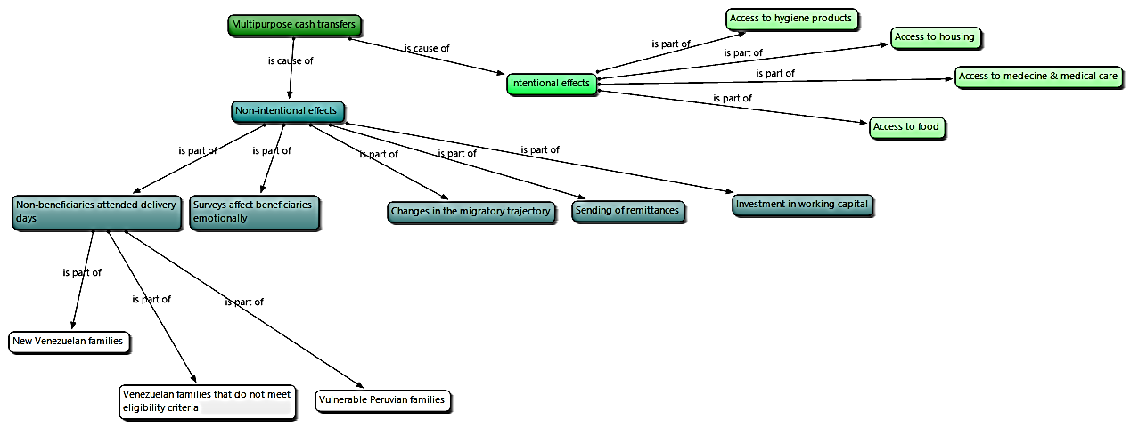
Source: Author’s Elaboration.

The intentional effects of cash transfers were to ensure access to basic needs such as food, housing, medicines and hygiene products. Mostly women were benefited because they were the ones who matched the project's targeting criteria.

With regard to the unintended effects of cash transfers, five effects were identified, although they were not specific to men or women:
- Cash transfers altered the migration trajectory of beneficiaries. One SC staff interviewee noted that a beneficiary decided to settle in Lambayeque to apply for cash assistance for her stay.
There was a moment when, in transit, we already reached a limit and we only took people who decided to stay. They thought it was one help, but when they found out about the second deposit to stay, they wanted to apply again. It was like people were stunned and said "no, I'm staying" (SC staff 8, woman, Lambayeque).
- SC staff, and in particular the cash transfers sponsors, pointed out that the eligibility surveys affected migrants emotionally because they reflected their extreme vulnerability and, to some extent, it affected their dignity. For example, they verbalized their situation of hunger and lack of food, the low nutritional quality of the food they or their children had consumed, the impossibility of consuming some products, and even behavior perceived culturally as degrading. In this case, the performance of SC agents was very adequate, as they gave emotional support to migrants, explaining that this information was required to assess their eligibility, and that they could respond sincerely since there was no judgment. While the survey had a relevant and appropriate design, the application process was very complicated for the respondents and pollsters, because of the emotional vulnerability.
It was hard because there's a moment during the interview you ask, "Over these last few weeks, how many times did you eat unpleasant and cheap foods?" When I mentioned that question to a woman, she started crying and said "Miss, for the last 7 days I ate poorly. I mixed some things or ate things given to me in the street like chocolates and cakes we received from supermarkets. That was the lunch for my children". Then I went on with the questions and the next question was "How many times did you stop eating, as an older adult, to feed your children?" Actually, we were all affected at first by listening to those who had gone through this, because when we asked those questions it was hard to hear the answers. I was telling the woman, “breathe, and calm down”. We even had to control our emotions as well. (...) for example, there was a question that we had to ask "Do you feed on insects or bugs?" The question was hard (...). "Have you consumed sunflower oil, olive oil or palm oil?" Those oils are very expensive (...) And people would say "no miss, I just eat rice with eggs, how am I going to afford to buy those kinds of oils" Even the most basic questions too: "Has the baby consumed breast milk, cow's milk, powder or canned milk?" and (the answer) was "no" (...) the alternative was to give them oats or soybeans that they could buy in the market for just one Sol, because it was the cheapest. (SC 8 staff, woman, Lambayeque).
- Transfer of funds: As mentioned above, some beneficiaries used cash transfers to send funds to their relatives in Venezuela.
- Investment capital for entrepreneurships: Some beneficiaries, especially single women, used the cash transfers to build up capital for self-employment.
- Non-beneficiary families attended the distribution days: the circulation of information going the rounds about the dates and places for the distribution of money cards to eligible beneficiaries generated the attendance of other people: new families who requested information or who wanted to apply; ineligible families (in general due to problems related to documentation) who came to request the revision of the evaluation process; and also vulnerable Peruvian families who wanted to apply for humanitarian assistance.
We had a problem because families arrived who were not on the distribution lists. (...) We had two people, the beneficiary and his partner, but none of them found the copy of the complaint (for the loss of his ID card) and they were crying at the door saying: "Miss, let me in, I also need humanitarian aid" (SC staff 8, woman, Lambayeque).

Effectiveness and efficiency of interventions
How efficient were the project management, systems and processes established?
The cash transfer sector consisted of five processes:
- Identification of the target population by mapping arrival points (such as terminals, tolls, streets and markets), but also by reference of allies (e.g. calls from merchants working at those meeting points, as well as those who attended the distribution days, which were asked for their data and were subsequently contacted. This stage was carried out by the cash sponsor.
- Application of the survey eligibility by the cash sponsor, using the KOBO system, available on Tablet or cell phone.
- Processing of the information by the Evidence Reporting and Assessment (MERA) specialist, which includes verification of identity, non-duplication matching (using UNHCR's consolidated information system), and calculation of the eligibility score.
- Preparation of money card distribution: includes the calculation of the amount of the transfer and preparation of the money card (carried out by the finance specialist), the logistics of the day of distribution (carried out by the logistics specialist), the call to eligible beneficiaries (carried out by the cash sponsor), and the coordination for the day of distribution (including verification of the quality standards by the MERA specialist).
- The management of the money card by the finance specialist, which includes the management of transfers and attention to user inquiries (e.g. for loss, blocking or loss of password problems).
The process of identifying the target population involved deploying the cash sponsors to different points of arrival, at times appropriate to the arrival of migrants (usually in the early morning). As mentioned above, due to high costs in major cities, many migrants did not stay overnight, and embarked on the same day.
SC staff members report that the processes were efficient: the target population screening goals were met, as well as the goals for identifying beneficiary families. The main reasons why families were unable to get through the eligibility process were due to:
- Incomplete or absent documentation of all family members. In these cases, they were asked for a police report for loss or theft, and a data check was made on a Venezuelan identification base. However, many target people were unable to obtain a copy of the police report due to lack of resources, discrimination or improper collections in police stations.
- The presence of all members of the family group at the time of registration. While initially only the "beneficiary" was required to be present at the time of registration, it was then considered that it may be necessary for everyone to go to register them in the digital bank. In some cases, it was difficult for families to attend together, because some adults were employed and could not be absent, either because they were not given permission, or because they were on daily jobs paid.
In addition, efficiency was analyzed by meeting deadlines for processing applications for up to 30 days. In the case of migrants in transit, the waiting time was adjusted to two days, and in some cases the distribution of the money card was processed on the same day.
SC staff believe that the information systems were adequate, as the questions attributed different scores based on the answers. They consider that the fact of not knowing in detail the scores of the KOBO system, helped to make the evaluation process more objective and with better protocols, and they maintain that the results of the system corresponded with the situation of vulnerability observed in situ.
According to a SC staff member, 70% of the families in the surveyed sector for eligibility met the criteria. Another problem that had to be managed was beneficiary quotas. Approximately 300 families were surveyed each month, so as not to exceed the monthly quota of 80 beneficiaries. After the quota was met, eligible families were scheduled for the distribution for the following month.
Another process that required a delicate approach was that of negative responses. Although the agents warned that if there was no call it meant that they had not passed the evaluation, many families showed up on the distribution days to find out the reasons why they got negative response. The staff managed the situation in a friendly, clear, assertive, empathetic and soothing manner. It consisted of explaining the eligibility protocol, causes, and options the family had.
It was the part of, "Hey, no, this is as far as you can go because you don't have the proper documents." Then he said, "No, man, please help me, I need to go..." And after that, I did feel I had to help them but sadly there was no way... I mean, there were only a few things I could say to them: "submit a complaint." I tried to help them as much as I could. I tried to give them other deadlines so they could come back, but in many cases I did feel the desperation for help, because they were in need and needed the cash to move forward, and in some cases, to eat. Because sometimes we had families that were there, and sometimes they brought some food and we could see that they ate desperately. And, well, there were very hard moments. Telling families that they didn't have what was required to continue the process. (...) In some cases, for example, they acted aggressively or sometimes they said bad words. Usually, I tried to calm them down and tell them that the help was there so that when they had the required documentation or the documents needed, they could come back and we could reschedule them. I used to tell them that help was not lost, but it was practically waiting there for them. Sometimes things happen to me for example, a man, now that I remember, insulted me saying: "Hey, you're taking the money they send us." I said: "No, sir, look, when you have the document, let us know and we can reschedule you." And he came back after three weeks... I said, "you are calm now," and he said: "yes." "As you could see, the help is here for you, but we have protocols to comply with," I said. I used to explain to them calmly, because we felt that the stress, they brought was a little severe. Well, very severe, actually. And if you argued at the time, perhaps things wouldn't have ended well. Always, one has to be calm, try to be as empathetic as possible and to walk a mile in someone else’s shoes. Those situations are very hard, actually, quite complicated, one can see and sometimes... well, in my view, I felt like my hands were tied when I wasn’t able to help them. (...) sometimes we looked for other relatives to see if they had any of their documents. As I tell you that has been the main setback: the lack of documentation (SC 4 Staff, man, Lambayeque)
Figure 4 Processes, activities, people and systems related to the Cash Transfer Sector
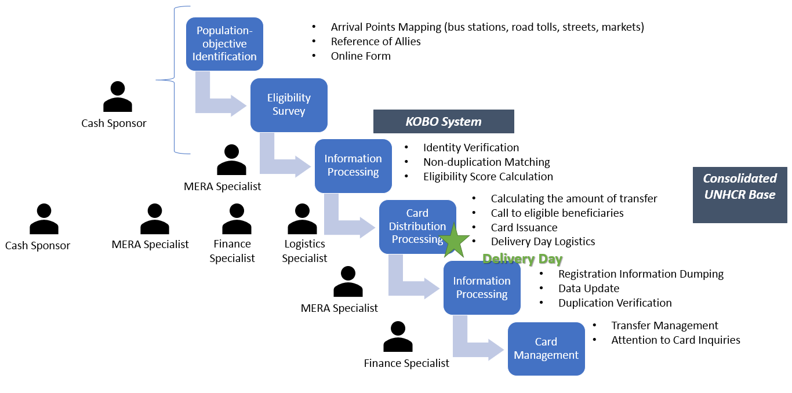
Source: Author’s Elaboration.
At a management level, the cash transfer sector of the project was composed of the national and regional coordination. The national coordination consisted of the project coordinator, the cash transfer thematic coordinator, the MERA and communications thematic coordinator. The regional coordination consisted of the regional coordinator, MERA, logistics, cash transfers sponsors and finance.
Figure 5 Management of Cash Transfer Sector
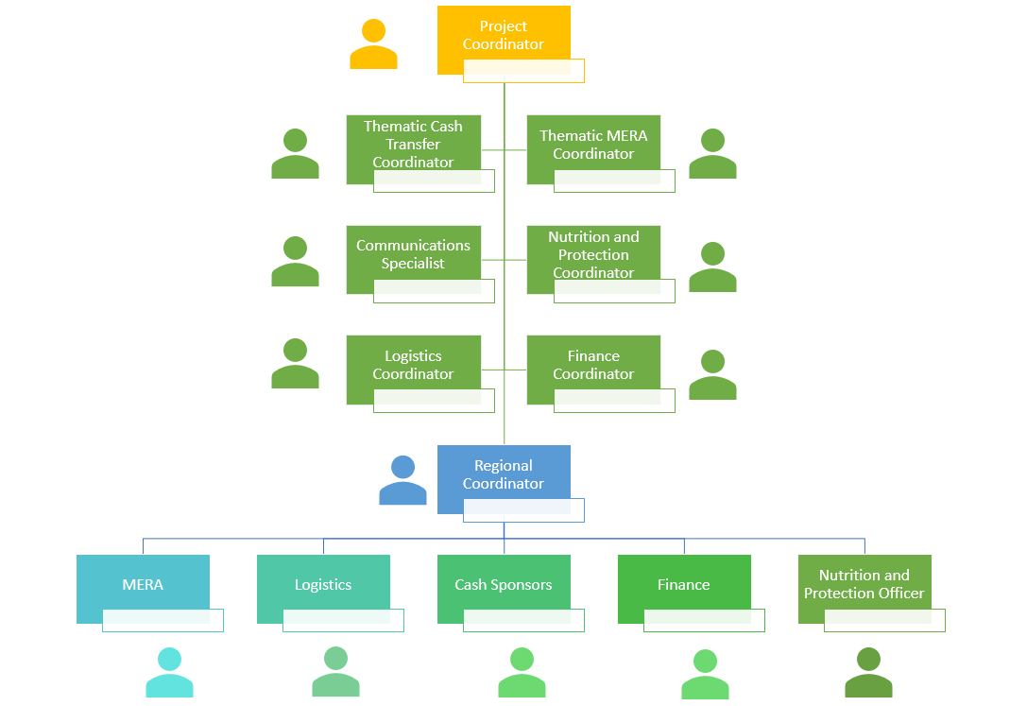
Source: Author’s Elaboration.

How efficient has the use of financial resources been in obtaining the results?
SC staff of the cash transfer sector argue that there was a suitable use of financial resources, but made two recommendations about the activities:
- In certain areas, especially for the identification of migrants in transit, cash sponsors did not use Tablets for safety reasons, because they were eye-catching devices and exposed them to be stolen or assaulted. Smartphone phones were used, more discreet and less valuable.
- Accessible, safe and available mobility at different times (early morning, late at night) was crucial to identify transit families. Certain cash sponsors say they made heavy mobility expenses and when they had the opportunity to move with the project's van they could identify more families.
Beneficiaries were also consulted on the number and amount of transfers. Some beneficiaries agreed that this is non-compulsory humanitarian aid, so they could not set parameters or demand more money. Others were honest and agreed that they were in a critical situation within the pandemic context and that they needed assistance.
Well, honestly, what they deposit is good for us, but perhaps there could be more deposits. Because we are really out of work and we have to take care of the baby and I am also about to give birth in less than a month and I have nothing to give her (Beneficiary 2, woman, La Libertad)
The help is ok, I mean, how could I complain if they are helping me? It would be very rude of me, I don’t complain, they are helping me and they don’t owe me anything. It’s fine with me, the small or large amounts they give (Beneficiary 4, woman, Lima)
Were gender issues included in the planning phase and component implementation?
Regarding to gender equality, SC staff reported that the gender equality approach was very present for beneficiaries, since the vulnerability of Venezuelan migrant women was considered in terms of dangers they were exposed to while transiting, domestic and parenting workload, exposure to family and domestic violence, and their health vulnerability in case of pregnancy or young children care. Gender approaches were considered during the planning and implementation phase of the project.
We have had (...) large families, I mean, despite the current situation of these households, there were many pregnant women, who had two, three or four children per family. Despite these conditions, we have found many pregnant women. Now, there have also been households where the father abandoned the mother during this journey, women who are also single mothers and taking care of their children alone (SC staff 7, woman, Arequipa)

Implementation of interventions
Were there any unforeseen changes?
SC staff reported two important changes from the cash transfer sector:
The first change was to reverse the schedule of distribution days. At the beginning, the design started with money card distribution and continued with talks and workshops. However, beneficiaries left after receiving the money card because they thought that was the main reason of their attendance. Reversing the order increased attendance to talks and workshops.
The second change was made within the context of COVID-19 health crisis: the identification and registration of new beneficiaries, as well as the money card distribution or changes due to loss or theft, were suspended; an additional cash transfer to former beneficiaries was provided; and finally, a telephone call monitoring system was implemented to notify transfers and track beneficiaries.
I think we have carried out the project as it was established despite the changes created by the pandemic, that modified the whole structure and the work model we have. We had scheduled to do more surveys, there were not many, but to apply selection surveys was part of the plan in order to handle a higher number of families. This activity must be done because that is the field work, about contact with people, but due to the pandemic it was not possible to carry it out, unfortunately. We also had replenishments, pending money card distributions, but the national headquarters already implemented other alternatives, we had to adapt and generate other ways to be able to serve our beneficiaries, having already moved to the Western Union model. Yes, there have been inconveniences which have not allowed us to finish our activities. But we are already adapting to other methods of attention than the ones that we initially had since the beginning of the project. But the overall purpose is that these beneficiaries would be taken care of fulfilling our goal as initially planned. (SC staff 2, woman, Arequipa)
Figure 6 Unforeseen changes in the cash transfer sector
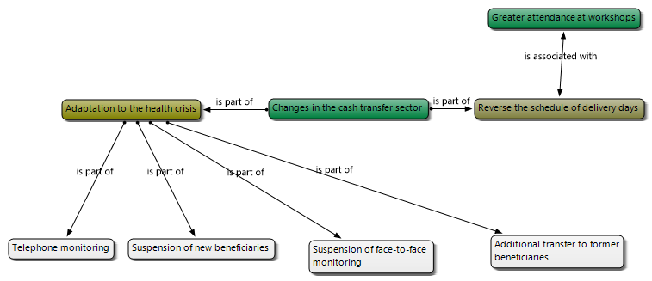
Source: Author’s Elaboration.
Were there any unexpected effects?
SC staff identified as the main unexpected effect that the attention provided to the beneficiaries affected the SC staff emotionally. Cash transfer sponsors were the project's benchmark for the beneficiary, as they identified and surveyed them. In addition to the emotional burden of the survey process mentioned before, they were also requested by ineligible individuals or beneficiaries who had doubts, consultations or problems, despite repeated efforts of the project to redirect these consultations and to coordinate with the appropriate communication channels. Cash transfer sponsors were perceived as visible benchmarks, which made work complicated.
We, as part of the Cash Sponsors staff, were emotionally burdened. And I tell you in all sincerity that us, the staff, were emotionally affected by seeing families with such burdens. It's always very easy to say we should not be overburden, but it's very difficult to accommodate everyone. You want to help everyone but you can’t because they are evaluated through a survey. (SC staff 8, woman, Lambayeque).
Another unexpected effect was related to staff safety issues: SC staff were visited at administrative offices, so they were forced to avoid being followed to ensure their safety.
To what extent were local capacities strengthened?
In the different regions, initiatives were formulated to articulate efforts with public institutions at human mobility tables, especially to generate social inclusion opportunities for migrants in the settlement group, both regionally and locally: DRE, UGEL, Area of Economic and Social Development of Municipalities, police stations, health facilities, DIRESA, DEMUNAS, CEM, and churches. Local capacities were strengthened in some regions such as Lambayeque, Arequipa and Piura, while in the case of Lima there was a refusal by local institutions to develop social inclusion initiatives for Venezuelan migrants.
Another aspect that emerged as a result of this, was the strengthening of humanitarian coordination with government entities. I think that might have been a little weak. In regions we made a lot of impact, trying to involve all government institutions. Private institutions also wanted to ally with us in order to work at the coordinating level to facilitate human mobility and be able to help these families. I think maybe this wasn't very mapped out at first, but it was done. (SC staff 2, woman, Arequipa)
Do women and men contribute equally to the development of the intervention?
Gender analysis of the positions associated with the component shows the presence of men and women serving in different positions, both in coordinating and in operational ones. A strong female presence stands out in national coordination, while in regional coordination, there is a presence of both men and women. For example, at the regional coordination in Arequipa, we see that the same number of men and women have held the positions. Certain positions have had only female or male staff, while others have had staff of both genders.
Figure 7 Gender distribution of general (national) coordination and regional coordination of Arequipa.
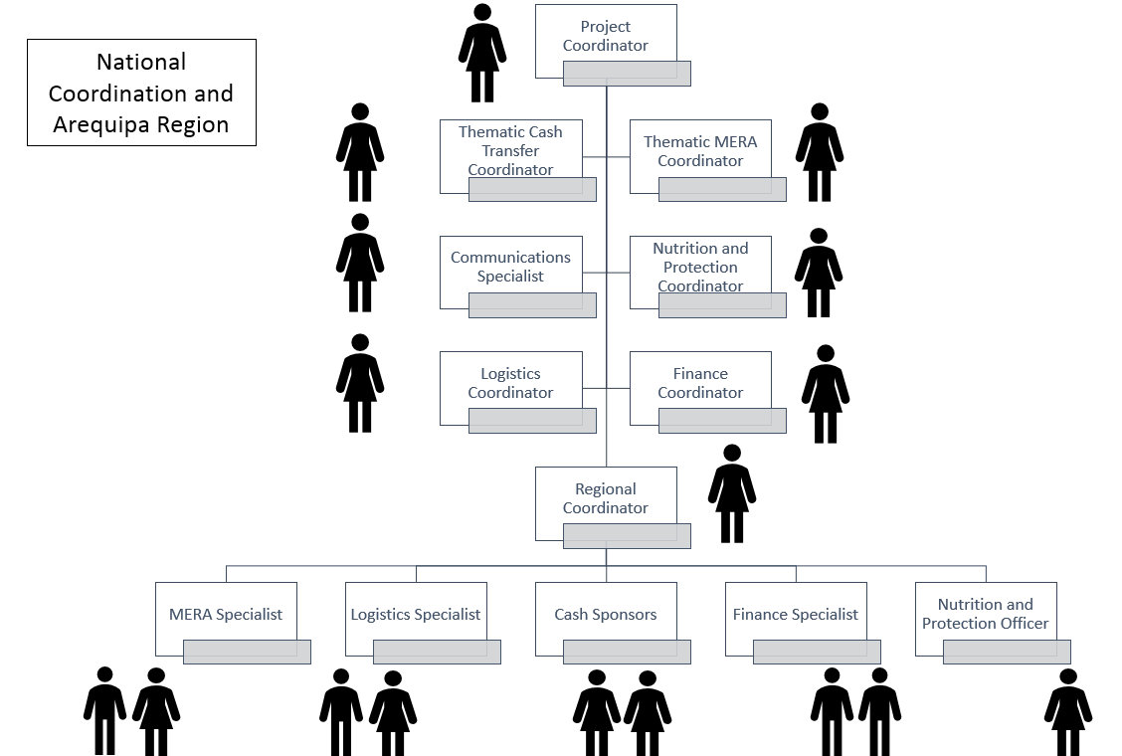

6.3 Nutrition
This sector seeks to improve the feeding practices of infants and young children from vulnerable Venezuelan and Peruvian populations.
Subsector: Infant and Young Child Feeding in Emergencies (IYCF-E)
Indicator 1: | Proportion of infants of 0-5 months of age who are fed exclusively with breast milk

The proportion of children 0-5 months of age who were exclusively breastfed increased significantly from baseline to endline – from 34% to 44%. This improvement was even more significant among boys than girls; the proportion of boys aged 0-5 months fed exclusively with breastmilk increased by 28 percentage points, while the proportion of girls who were exclusively breastfed remained the same.

Figure 18. Proportion of infants 0-5 months of age fed exclusively with breastmilk at baseline and endline, disaggregated by sex
Indicator 2: Minimum Dietary Diversity-Children | Proportion of children of 6-23 months of age who received food from 4 or more food groups
The proportion of children consuming foods from four or more groups increased by 30 percentage points from baseline to endline to 100%, overall and among both boys and girls.

Figure 19. Proportion of children of 6-23 months of age who receive food from 4 or more food groups, disaggregated by sex
To what extent did the implemented component’s activities achieve the goals, objectives and indicators?
Qualitative interviews reveal that the nutrition component of the project achieved good results in raising awareness in informing mothers, parents or caregivers. The messages have generated an impact on beneficiaries, especially the communication material that was shared during the COVID-19 health crisis through WhatsApp groups.
However, the results are not as encouraging at the level of nutritional practices: many families consider it expensive to buy fruits, vegetables or animal protein, although some are obtained through gifts or special purchases.
I want to comply (with the advice), which is very good. I would like to comply with all of that because I want to give everything to my little girl so that she will not get sick. Imagine, where I would take her if it, she gets sick. With our economic situation, it is very difficult for me to acquire the food they tell us to. Then sometimes I have to give her what the nuns give me or something else. In order to feed her, I try to buy her fruits; a banana, a tangerine, (...) little by little I buy them for her because I don't actually have the money to buy them all at once. So, I can't comply with that diet, because I need more money in order to buy those things for her (Beneficiary 2, man, La Libertad).
During my pregnancy I was a little depressed and they assigned me a psychologist because I wasn’t even trying to get better. I would clean for the woman, but sometimes it wasn’t enough for me. This forced me to go out and sell things sometimes. I went out to sell lunches or tizanas; every day I would go out to sell something and I hardly ate because I was on the street. I was out selling which is why I arrived home late and didn’t eat much. Instead of gaining weight, I was losing it. I ended up weighing 60kg and I was supposed to be about 70kg, I was underweighted by several kilos. The doctor told me that this was hurting my baby, that's when I was assigned to a psychologist. I told him that because of my situation I had to have food. He spoke to me, helped me and they started feeding me. I started to gain a little weight, but when the girl reached 6 months of age, she suffered from anemia because of my malnutrition during pregnancy (Beneficiary 2, woman, La Libertad).
In several cases it can still be noted that there is no planning of the children's menu: they feed on what can be obtained. As a result, in some cases children have been diagnosed with anemia and underwent treatment. Diagnosis of anemia is an alert for mothers, fathers and caregivers, who strive to provide iron supplements and an iron-rich diet (sangrecita, liver, etc.).
She was diagnosed with anemia at 6 months of age and I had to get other kinds of food. I was told I had to buy her sangrecita, potatoes, carrots, yellow foods and yellow fruits. I had to change her diet. The daughter of the woman that I cleaned for has a vegetable stand and helped me. She brought me squash and bananas. She helped me with that in order for my girl to recover from anemia because it was a delicate condition. (Beneficiary 1, woman, Lima)
Project staff were also consulted in interviews if they identified any explanation of the differentiated nutrition outcomes between boys and girls. While no gender differences were made in the project's activities, a nutrition professional emphasized that this could be attributed to the conception that male children are hungrier, although she has not heard it directly.
I've never made any changes because the recommendations are global. I have never heard comments like "little boys eat more." Actually, as far as I can remember, I haven't heard anything like that. I think it's similar in Peru. They think that a boy, because he's male, can eat a little more or maybe he’s a little hungrier. But the truth is, now that I remember, I have not heard this openly (SC staff 5, woman, Lima).
What were the main factors that influenced the achievement or not of the objectives?
Two negative factors that affected the achievement of the objectives were identified:
- The lack of economic resources related to job instability and precariousness and the state of emergency of COVID-19. Lack of income also affects the nutrition of adults, who eat less often, or prioritize children.
Their situation is really hard. Some people, for example (...) tell you "I haven't eaten for two days" or "I'm just eating (...) once a day." As parents, they are not eating in order to feed their children. Many of them go out to ask for food. (SC 6 staff, woman, La Libertad)
- The instability of Venezuelan migrants in their daily lives does not allow them to adequately plan or organize food.
But, honestly, in this population it's a little complicated to do that because they don't live in one place. They move constantly because of their vulnerable condition, since most of them have to go out and sell with their children and generate income in order to eat that day or pay for their rooms. So, it's quite complicated (SC staff 5, woman, Lima).
Did the interventions reach target groups and individuals within the areas of intervention?
The interventions reached the level of conceptions and attitudes to the target individuals:
- Most pregnant beneficiaries reported having cared for their diet and considered it important for their baby's development;
- Most beneficiaries who are mothers of children aged 0 to 5 months exclusively breastfeed because they consider it important for their child's health, immune system and development.
- Most beneficiaries caring for children under the age of 2 years old consider it important to continue breastfeeding and progressively introduce complementary feeding.
- Most beneficiaries who care for children from the age of 3 years old consider important a varied diet in suitable portions, containing protein, fruits and vegetables.
Interviewer: What did you think of that nutrition talk?
Beneficiary: Very nice, besides giving examples, they addressed people very nicely. The subject was well organized. There were quite a few people there, they included me because of the anemia and I also told them about it. (Beneficiary 1, woman, Lima)
At the practical level, only one beneficiary stated that she was able to steadily implement nutrition recommendations in her daughters' diets. At a minimum level, unhealthy nutrition practices (use of milk in formula, teas and broths, among others) were identified. This shows that in the settlement group, it is vitally important to address access and stability of employment, in order to ensure that practices are sustainable.
Did women and men benefit equally from the intervention?
At the time the strategy was designed, the focus was on direct caregivers, i.e. mainly women, because they are in charge of household parenting. However, when the strategy was adapted to the context of the pandemic through informative messages on WhatsApp groups, men also received the information. The interviewed beneficiaries considered it important to take into account nutritional recommendations, for their children as well as on a general level.
What happened as a result of the component and the coordination between the different actors involved?
At a sustainability level, SC staff and beneficiaries express that there is sustained nutritional monitoring of pregnant women, infants and up to 3-year-old children, due to universal access to the Comprehensive Health Insurance (SIS, in Spanish). This Insurance ensures prenatal and pediatric check-ups, medical and nutritional care, hemoglobin laboratory tests and access to nutritional supplements.
COVID-19 crisis has also originated various ideas on how to ensure the feeding of Venezuelan migrants. Some participants mention the option of organizing soup kitchens or financing lunches for migrants. Likewise, some solidarity networks between Peruvian and Venezuelan neighboring families were also organized. Note that discrimination and poor community integration complicate the collaborative organization of these initiatives:
There are many families staying in Piura. As I tell you, we have known them since 2018 and they have 2 years here approximately. So those families have been able to join, let’s say, our society and are part of it like everyone else. But I think that ease and openness that the Venezuelan people have is what actually allows you to work with them. They're very open. They are people open to support, to contribute, to cooperate even with what little they have. They are very willing to work and to do their best. I believe that if those kinds of activities are organized, this could be achieved (SC staff 2, woman, Piura).
What you can do is work with soup kitchens. In other words, a few of them can help some Venezuelans with provisions, so that other Venezuelans can reach an agreement to help distribute the food within their own community. For example, I give you a sack of rice, 20 kilos of noodles, 10 kilos of beans and you can include up to ten more Venezuelan families. And in fact, it helps. You don't prepare it, the soup kitchen does. Then, you give them the input. I know there are NGOs working with soup kitchens. Another alternative is Vaso de Leche (a milk distribution Program). Those are good alternatives. You tell them they can help them. You can do the same with municipalities, but there are also self-contained soup kitchens governed by municipalities. Those are options for you to ensure their food security. I think that at Vaso de Leche, they are registered until they are 3 or 4 years old. I am not sure, but you need to have a little child to be in that program. The Soup kitchens is one area that I visited when I was identifying the beneficiaries. I have talked to many soup kitchens. The truth is that some didn’t accept Venezuelans, only accepting their previously registered members - that is, they didn’t accept new members - and there were several Peruvians among them. Others did accept Venezuelans, but they had to pay like anyone else. It was 5 soles; I think… Those two cases, and one other did not admit Venezuelans. So, the question is to create alliances or agreements to work with the community and make it feasible and sustainable. (SC staff 5, woman, Lima)
There are neighbors too. For example, the woman was a single mother. She had a baby, who was born just before the lock-down. She has two more children, I think, and lives with her mother, but her mother is elderly. So, what the neighbors have done is to give them food. Within this context, for example, a family gives them food on Monday, another family on Tuesday, and so on (...). That's what they have done in their community (SC 6 staff, woman, La Libertad)
What are the intended and unintended effects on women and men?
For women, the intended effect was to improve nutrition information to pregnant women, lactating women and mothers/caregivers of children under the age of 3, as well as to all family members in general, since women are responsible for the children rearing and food. An unintended effect was to improve men's level of awareness on the issue, ensuring that they secure a portion of household income for healthy food purchasing.

Effectiveness and efficiency of interventions
How efficient were project management, systems and processes established in the project?
The processes of the nutrition sector were severely changed due to the COVID-19 health crisis. At the beginning, the component consisted of four activities:
- Briefing
- Training Sessions
- Face-to-face personalized Counselling
- Support Groups
- Workshops for Sponsors and Health Officers.
In the context of the pandemic, the component was restructured. The briefings were suspended, because there were no new beneficiaries. In addition, two follow-up processes were established:
- Nutrition Information through WhatsApp
- Telephone Counselling
SC's nutrition sector staff stresses that the efficiency of telephone counselling is lower than in face-to-face advising (raised in the design), since the latter allows for the collection of more accurate information on the nursing technique, or on the portions and consistency of preparations. However, telephone counselling has been essential in the context of the pandemic, due to the impossibility of an in-person meeting.
It's true that we've done counselling, yes. Counselling allows you to see the problem. In the virtual session, we called back all those mothers who received training sessions but this was not consistent. To see an impact, you must have at least three to four sessions within a minimum period of six months with the same people from a program. So that you can see if a change was really made regarding knowledge, practices and attitudes. I would not be able to measure with only one test to see change in someone who has participated only once even though there are people who have worked on all four activities. Obviously, they are interested. There is greater interest and they have the possibility to do so, but there are very few. In addition, in my experience, to review the topic of breastfeeding, we have to generate an observation sheet. In other words, we have to share more time with the mother and analyze her point of view on a specific topic. On visits at different times, I can see whether it has improved or not, according to the problems. It is the same with feeding. There is a tab where you see the child's food at mealtime, or they just send photos of the dish. You can evaluate if food groups are complete, how the child is being fed and follow up with "How did your child eat? How did he do? Is there any difficulty?" Follow up a little bit more... That way you ensure a change in behavior because you can receive the information, since changes in behavior are achieved through continuous follow-up (SC Staff 5, woman, Lima).
Figure 8 Processes, activities, people and systems related to the Nutrition Sector
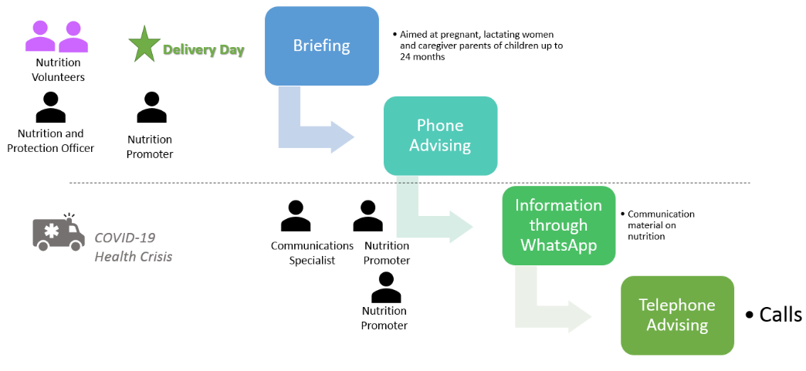
Source: Author’s Elaboration.
How efficient has the use of financial resources been in obtaining the results?
In terms of efficiency in the use of financial resources, SC staff members made no recommendations or comments.
How effective were strategies to improve gender equality at both the participant and project management levels?
One of the unintended effects was to raise awareness among parents (who were not primary caregivers in general) about the importance of the varied and balanced nutrition of children.
Were gender issues taken into consideration in the planning phase and project/program implementation?
Yes. Primary caregiver of boys and girls were convened, regardless of sex. In addition, the advice was given for boys and girl alike, without any discrimination.
Is the design of the intervention gender-differentiated?
The intervention is designed to improve the nutritional practices of pregnant women, lactating women, and toddlers up to 24 months of age, regardless of gender of the caregiver.

Implementation of interventions
To what extent were local capacities strengthened?
The nutrition sector, since it is related to health care for pregnant woman and children from 0 to 3 years old and is covered by SIS. First, because the messages of the project and those of the health staff align with the recommendations of the World Health Organization, so they reinforce each other. Second, because the coverage of the SIS guarantees sustained access to health care and treatment. However, some beneficiaries had difficulties in accessing the service, so it is recommended to raise awareness among DIRESA managers about the right to health of Venezuelan migrants and their vulnerable situation. Finally, from age 3, children lose health coverage, and often they continue with anemia problems, although their families are unable to afford multi-month treatments, consultations, examinations, supplements, and specific diet.
I take my daughter to the Dos de Mayo Hospital to treat her anemia; there is a psychologist and a nutritionist on staff. I had an interview with the psychologist when I was pregnant, also when my daughter was a baby and had anemia; it helped me a lot. (...) Yes, with the SIS insurance, but I had difficulties because the person that registered me got the date wrong and at the time of my delivery, it was recorded in the system that I had already given birth. I said “check my belly, I’m about to deliver. -The thing is they made a mistake and it is beyond our control”. Afterwards, I talked to the director and she acknowledged that it was a mistake and she would help me; I said it was all right. At the time of giving birth, they told me the director was on vacation and they couldn’t help me. In the end, she went from her home to the hospital to check on us. (Beneficiary 1, woman, Lima)
Were there any unexpected effects?
Yes. Parents who were not primary caregivers were sensitized through WhatsApp messages.
Were there any unforeseen changes?
The first unforeseen change was in the context of activities due to COVID-19.
The second unforeseen change was the schedule of activities on distribution days.
The third unexpected change is related to a design activity that included support groups for lactating women and mothers/fathers/caregivers of children of 0-2 from Peruvian and Venezuelan families. Whereas this action would strengthen social inclusion in local communities, it might cause frustration over the differences of benefits for Venezuelan and Peruvian families, due to the discrimination and feeling of neglect of vulnerable Peruvian communities. Therefore, it was decided to work only with Venezuelan families.
At the beginning, the idea was to work, for example, in the whole protection and nutrition area integrating the Peruvian and Venezuelan populations. (...) It was a space to attempt to integrate both; however, it was dismissed because there was a risk that (...) a Venezuelan mother would comment, or a Peruvian family would find out in some way, that she was receiving humanitarian aid while the Peruvian family received nothing. Unfortunately, many people value and need money. We were asked to inform them about protection and nutrition subjects which are very important; however, for a beneficiary in a vulnerable and urgent situation, money is more important because it will solve their immediate problems. Another issue is that the Venezuelan population we are working with has settled in vulnerable areas where there are also vulnerable Peruvians. Evidently, the migrant's situation is very complicated. Refugees are even more vulnerable because they are outside their country; their migration status is irregular; they lack academic training, among other factors. However, it is difficult for another vulnerable Peruvian to understand this. I believe this is why we decided to divide up the areas. It would no longer be one meeting place, but separate spaces. (SC staff 3, woman, Lima)
Do women and men contribute equally to the realization of the intervention?
In the case of the nutrition component, SC staff is predominantly female. There are no adverse effects from this distribution.

6.4 Protection
The objective of this sector is to promote the safety and well-being of Venezuelan children and women affected by the migration crisis in Peru.
Indicator 1: | Number of individuals participating in child protection services
13,710 adult beneficiaries were trained on protection issues, relevant information was provided to adults through leaflets, brochures and communication materials as well as referral mechanisms to protection services to ensure that abused and/or at-risk children can be protected. In addition, 4,524 children (2,220 girls, 2,304 boys) had participated in Child Protection services.
Indicator 2: | Percentage of participating parents who “strongly agree” that their child’s emotional health has improved as a result of participation in the child friendly spaces
Approximately 71% of parents “strongly agreed” that their child’s emotional wellbeing improved as a result of participation in the SC child friendly spaces.
Indicator 3: | Percentage of households reporting improvements in their feelings of well-being and ability to cope at the end of the program
Nearly all (95%) of the beneficiaries interviewed during endline reported improvements in their feelings of well-being and ability to cope at the end of the program, indicating positive effects of the psychosocial support services provided by SC.
Indicator 4: | Percentage of households reporting an improvement in the way they are being treated by the recipient community
When asked about their treatment by the host community, over three-fourths (78%) of beneficiaries reported an improvement since their arrival in Peru. Among them, those beneficiary families in the settlement group reported better treatment than those families in the group in transit; this can be attributed to the fact that beneficiaries in settlement group intend to stay long-term in Peru and integrate into the Peruvian society, while those in transit may only be passing through and, therefore, do not have longer term interactions with Peruvians.

Figure 20. Percentage of groups in transit and settlement groups reporting an improvement in treatment by Peruvian community
To what extent did the implemented component’s activities achieve the goals, objectives and indicators?
The protection component consisted of the following activities:
- information sessions about violence
- workshops for adults,
- workshops for boys and girls
- workshops on gender-based violence and discrimination;
- lectures at educational institutions;
- attention of cases;
- Socio-emotional monitoring.
Regarding the relevance of the intervention in the field of protection, SC staff said that the socio-emotional fragility of adults and children was clearly evident before the informative sessions.
Many parents feel a bit upset and uncomfortable there. Sometimes they inappropriately correct the children in a very harsh manner; that is why we emphasize that issue. Many of them are very emotionally burdened due to stress. In the workshop, we always state that this can often be detrimental to their loved ones, such as their children or partners, and since they feel very irritable and sensitive, they can take it out on their children. (SC Staff 6, woman, La Libertad)
Yes (It affected him), and not only because we moved to another country, but he experienced xenophobia at such a young age. One day after leaving school, he said crying “mom, I want to move back to Venezuela because I don’t have friends here; they don’t want to play with me because I’m different”. This coming from a 4-and-a-half-year-old boy which was very painful for us because we saw that it impacted the child as well. We asked the teachers to talk to the other children, although it was not their fault because the children simply repeat what their parents say. Thank God, we overcame that episode. Yet sometimes he cries when he thinks of his cousins who have nothing to eat. He realizes this even though he is only a child. (Beneficiary 5, La Libertad)
Workshops for children approached the migration route on a map; a session to prevent violence and child sexual abuse, hand washing and they also received a snack.
At the level of the effects, both staff and beneficiaries themselves reported positive effects on children, men and women, and some techniques were reused by beneficiaries:
They (the children) left the workshops very calm, more motivated and comforted, since we worked deeply on the emotional aspects (...) they expressed their emotions and concluded with positive comments that they brought with them to each session.
They (the beneficiaries) retain many emotions and feel very grateful when we call them and let them know there is a space and time for conversation. This space was created for them, their families, and their emotional well-being. They appreciate the call because there is no one who understands their context and can listen to their experiences, so when they share their stories, they feel more relieved. We give them recommendations to handle and control their emotions. (...) some people even told me that they practiced the activities we taught them very often, writing all the negative emotions on a sheet of paper and writing positive thoughts that change those emotions on the backside side. (SC Staff 6, woman, La Libertad)
Note that although the beneficiaries recognized the usefulness of the protection service in relieving anxiety about migration and economic situation of households, very little was said about the impact of workshops in terms of gender-based violence (GBV). Some mentioned they did not require these services, but we have to change the female beneficiaries up to three times because they did not attend the telephone appointment nor did not want to comment on their current situation. GBV in households seems to be a taboo subject for Venezuelan migrant families, and the lack of clarity from the qualitative data indicates that cases are under-recorded.
What were the main factors that influenced the achievement or not of the objectives?
The severity of the protection cases implies the joint action of various entities. However, beneficiaries report that they do not have access to protection services because they are discriminated. Although emotional counselling provides support and information about other options (health centers, police stations, etc.), it cannot replace institutions.
They say they were ignored when calling 113 for assistance. We have also found that 5 families with COVID-19 symptoms called 106 and didn’t receive attention because they were Venezuelans or their phone calls were cut off because they did not have a Peruvian DNI (National Identity Card). So, one of them went to Chimbote, not far from here, for medical attention because they no longer wanted to help him; all of these situations affect them emotionally and we are working towards solving these issues. (SC staff 6, woman, La Libertad)
In addition, the COVID-19 health crisis aggravated the problems of coexistence in households.
How did the project cooperate with other similar projects in the territory, at the national level, with other OFDA and FFP partners and with the State’s priorities?
For monitoring of violence or neglect cases, we identified children and adolescents who were abused, presented signs of neglect, were at risk or unaccompanied by their parents or caregivers. SC staff referred cases to institutions such as NGOs, Ombudsman's Office, Demuna, PNP and MIMP.
In addition, they called on the protection institutions on distribution days to report protection subjects:
We created an additional space to reinforce child protection and human trafficking issues through DEMUNA, the Women's Emergency Centre, the Police, etc. In other words, we always tried to invite some of these institutions so the beneficiaries would know that they exist and learn how to submit their complaints in cases that required that type of intervention. (SC Staff 7, woman, Arequipa)

Effectiveness and efficiency of interventions
How efficient were project management, systems and processes established by the project?
At the efficiency level, the processes of the protection component were effective. We worked gradually to adapt the methodology to the family’s availability, and developed counselling and information through WhatsApp that included support material.
Figure 9 Processes, activities, people and systems related to the Cash Transfer Sector
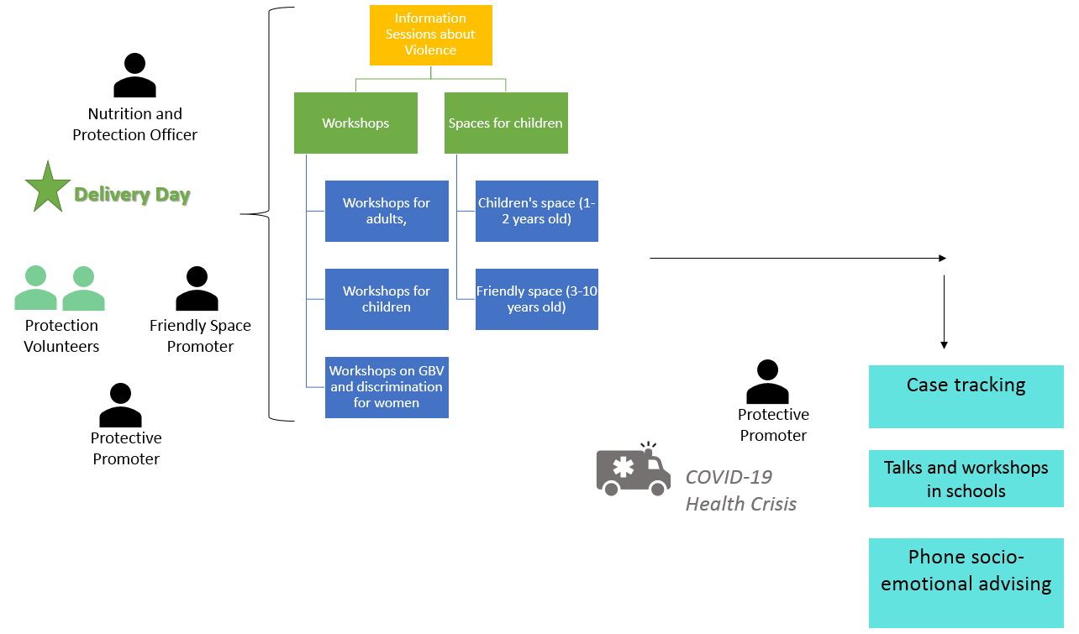

How efficient has the use of financial resources been in obtaining the results?
The aspect of efficiency most emphasized by the CS staff relating protection was closely related to the workshops scheduled with beneficiaries because attendance was less than 50%. This was mainly due to the fact that migrants prioritized activities such as paid work, which often depended on each day and where permits could not be applied for.
Staff proposed developing an incentive system such as ticket refunds. Note that during the health crisis, the strategy was changed to a telephone counselling, which was in greater demand by the beneficiaries, particularly women.
Were gender issues taken into consideration in the project and program planning phase and the implementation?
The design of the component incorporated in its design the socio-emotional needs differentiated by sex and age. Men have been shown to be more prone to employment-related stress because of their role as providers. Women were overwhelmed by feeding, childcare, (...) education (and remote education in the health crisis). Moreover, some women were single mothers engaged in sale or small trades.
The perception of their own vulnerability and precariousness also affects their self-esteem:
They have not come to ask but the circumstances force them to do that, and they feel very bad because most of them are professionals. They never imagined having to ask for spare change in order to survive, such a situation is very difficult (SC staff 6, woman, La Libertad)
In the case of the children, the anxiety came from not having access to enroll in school due to lack of space, or due to the requirements of technological equipment to follow the classes remotely. Children are victims of school violence and discrimination, as well as the loss of referrals such as family members, friends, school and the neighborhood in Venezuela. This affects them emotionally, to the point that some children wish to return to their country of origin.
Because of the virtual classes and their needs too. For example, they don't have a TV, they don't have a computer, the only thing they have is their cell phone, and they have a minimum number of contacts. Most families have 4 members or more. The average family has 5 because they have 3 children, and few families have 2 children. Sometimes, they have 3 children around same age, or they have 5 children and their ages are close. For example, you have one six-year-old, an eight-year-old and a ten-year-old or something like that. The only way they can see the class is through the cell phone. So, one uses it almost all morning, the other, in the afternoon, and the other, at night. It has become very difficult for them to adapt to this situation in which they do not have all the necessary tools and some of them don’t have the material to complete the homework. This situation has generated a little more stress, because many mentioned that it is difficult when the children don’t understand why they can’t send it like their classmates do. (...) There are some who are already in school. For example, they mention that there is a little bit of discrimination for the fact that they are Venezuelans, besides that the education is different. It seems that it is a little more advanced here in Peru, so they have a certain amount of stress, because they still have to improve to the level of Peru. Also, we have discovered that, in the children’s workshops, there is a very beautiful dynamic with warm words and an open heart. During the workshops, we say that the heart can be damaged by words many times, and they would agree and say that they are insulted by words like "Venecos"; I think it was that term or other insults for them that were very difficult as children to accept. Many miss their friends from Venezuela, they miss their beaches and their own schools. Some have already adapted to here, but others haven’t, so when we talk about that subject, they begin to talk about how they missed their country very much. Things are good here, but not as nice as in Venezuela they say. (SC staff 6, woman, La Libertad).

Implementation of interventions
To what extent were local capacities strengthened?
The strengthening of local capacities was achieved through an articulation with the Ombudsman's Office, PNP office, the health centers where the talks were also given, some churches and NGOs that provided their premises.
Joint activities were planned with certain partners, although these activities could not be carried out in the context of the health crisis.
Were there any unforeseen changes?
Two important changes were made to the component:
- Changes in the methodological guideline of the workshops: due to the low attendance at the protection workshops, the methodological format was chosen to be adapted to a single day (the day of distribution). In addition, some aspects such as incorporating a space to "close emotions" were improved, since space generated many negative emotions such as sadness, longing, anguish, fear, doubt, insecurity.
- Elaboration of a telephone counselling protocol in the framework of the health crisis: The methodological guideline was adapted to identify if a user is sad this meant for the sponsors to adapt to hearing information without the visual report of the situation.
As psychologists, it has also been a process of adapting to way of speaking. For example, it has been very complicated because I have always been used to making eye contact, and seeing people's body language. When a person understands the message well, it is very noticeable with their non-verbal language that shows how they are feeling. Then, based on that we, well at least in my case, I had to adjust my speech and express myself with gestures too. There are many strategies to reach people, but visualizing in this context was a little complicated, but we have learnt indeed. I believe personally I have learnt, for example, to listen and interpret silence as well as to recognize when they are listening and paying attention to you or not especially when they are experiencing some strong emotions. This makes the work we do with them easier, and helps them feel a little more confidence over the telephone (SC staff 6, woman, La Libertad).

6.5 Humanitarian Coordination and Information Management

Indicator 1: | Number and percentage of humanitarian organizations using information management services
There are 7 (100%) organizations that have used information management services for multipurpose cash transfer projects: SJS-Encuentros, Save the Children, World Vision, RET, CARE, CARITAS Peru and UNHCR which leads the coordination between humanitarian organizations. Since November 2019, an agreement has been in place for the creation of a common beneficiary database to improve coverage and reduce duplication of humanitarian assistance.
Indicator 2: | Number and percentage of humanitarian organizations directly contributing information products
The 7 organizations mentioned above contributed directly to the information products (100%). These products have improved program coverage and have reduced the risk of duplication of humanitarian assistance in the CBI Working Group.
Indicator 3: | Number of products provided by information management services that are used by interested parties
Information management services have provided one (1) product widely used by all interested parties. This product is the common virtual platform for beneficiary registration, which is a type of a shared cloud. It contains information on the type and number of identification document of beneficiaries reported by organizations that carry out cash transfer activities.
The project worked with various partners from national, regional and local levels in order to ensure comprehensive care, articulated implementation and non-duplication. Cooperation took place at several levels:
- UNHCR-led Migration Table: brought together public institutions, international organizations, NGOs. Updates on implemented activities were shared here and thematic collaboration activities (for cash transfers, nutrition or protection) were coordinated as well
- Regional tables with regional and local governments, decentralized state agencies and churches.
- A network of local partners to identify cases and provide humanitarian assistance (shelters, soup kitchens)
- A team of volunteers supporting regional teams, especially on days of money card distribution.

Figure 10 Elements of the Cooperation Component
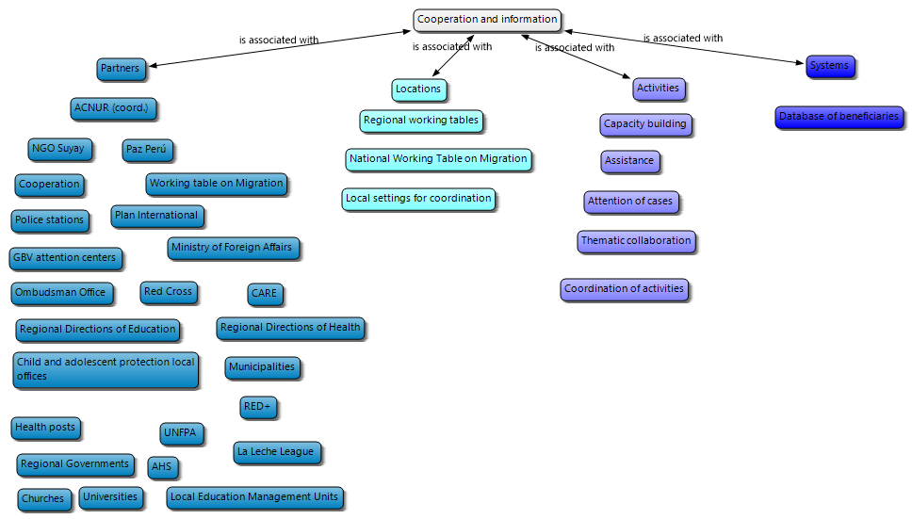
Cooperation was efficient for partners and SC staff interviewed. The use of a single system for beneficiary registration, with a unique identification code, ensured non-duplication. Thus, ensured a greater aggregate scope of actions, and coordinated interventions at territorial level (at spaces, dates and processes level). This process is relatively new in Peru, as partners interviewed point out.
It was almost impossible for beneficiaries to identify whether the work of humanitarian organizations was coordinated. They emphasized that there were very few organizations helping Venezuelan migrants, although some beneficiaries did acknowledge the aids, they received from other organizations (e.g. health or food access from church members).

7. CONCLUSIONS

7.1 Achievements and results:
At the household level, food security indicators suggest that there has been no improvement in the food consumption score, with 65% of beneficiary families having an acceptable diet; 24%, a limited diet; and 10 %, a poor diet. As a result, beneficiary families have more often resorted to coping strategies such as limiting portion sizes of meals or consuming cheaper or less preferred foods. There has been a 12 percentage point increase in the incidence of families suffering from moderate or severe hunger. This situation can be explained by the reduction of available income caused by the state of emergency and immobility in the country, being households with children under 5 years old the most affected.
These findings showed that IYCF practices among beneficiary children improved. The proportion of children 0-5 months of age who were exclusively breastfed increased significantly from baseline to endline – from 34% to 44%. When looking at the disaggregated data on this indicator, it was found that the data remained the same from baseline to endline for girls but increased from 32% to 60% for boys. Additionally, all children received the minimum dietary diversity (i.e. Received food from 4 or more food groups the previous day) at the endline, which was likely contributed to by the talks and counselling provided by the project.
Beneficiaries increased their access to appropriate accommodations and improved their access to non-food items such as bedding, kitchen utensils as well as adequate access to water. Beneficiaries reported feeling more integrated into their environment and that the treatment they receive from the Peruvian community has improved.
Qualitative data confirms these results. Beneficiaries, SC staff and interviewed partners recognize and value the vital usefulness of the project and the positive influence it has had on the well-being of beneficiaries. Cash transfers have allowed them access to basic items such as food, housing, medicines and hygiene products. Nutrition activities have guided them on their feeding (in the case of pregnant women) and the feeding of children aged 0-24 months, with emphasis on the prevention of anemia. Protection activities have raised awareness of domestic violence, particularly violence against children and adolescents, and gender-based violence (GBV); including children, on self-protection from risk situations. The project also informed about the reporting channels of violence situations, and strengthened socio-emotional well-being through workshops that helped build resilience. Cooperation activities and information system management made it possible to avoid duplication of access to the different projects, thus broadening the scope of humanitarian aid.
However, the impact of the project has been mitigated by external factors. Two main mitigating factors have been identified in achieving the objectives of the OFDA-FFP project. The first mitigating factor is the precarious means of support that ensure a process of stay with social and economic inclusion. Families of Venezuelan migrants find it very difficult to access safe, stable and adequately paid employment; adequate and economically accessible housing; access to the public health system and public education for children and adolescents. The few opportunities for inclusion they encounter, as well as xenophobia and discrimination in community interactions extend these periods of stay, turning them into precarious forms of life under high vulnerability, coupled with a sense of frustration and rejection.
The second mitigating factor identified was the COVID-19 health crisis, and the declaration of a state of emergency since March 6. Movement restrictions, closure of commercial premises and health control protocols for staff over an extended period of time reduced opportunities for migrants to generate income. This significantly affected family economies, which in turn affected living conditions in inadequate and overcrowded housing. Certain beneficiaries had difficulties in accessing the project: they were unable to collect money cards (for new beneficiaries) because of suspension of deliveries, or to process money cards due to loss or password problems. Other beneficiaries became infected with COVID-19 and found it difficult to access medical treatment.
The project's interventions reached target groups and individuals within the areas of intervention: migrants in transit and in stay, families with pregnant and lactating women, older adults, people with disabilities and children under 2 years of age.

7.2 Effectiveness and efficiency of interventions
Project management was efficient, as it was coordinated at the national and regional levels in Lima, Arequipa, Piura, Lambayeque and La Libertad. At the process level, various adaptations were made using the different media, as well as redesigns to adapt to the routines and rhythms of the beneficiaries. At the systems level, the KOBO eligibility system allowed the identification of beneficiaries through an objective scoring system, while the use of the Migration Desk database managed by UNHCR allowed the extension of the scope of the different projects, avoiding the duplication of beneficiaries.
The use of financial resources was efficient, in particular by adapting to the central distribution day format which concentrated almost all the beneficiaries, and by adapting a telephone counselling device and a communication campaign via WhatsApp.
Strategies to improve gender equality were also efficient. At the participant level, the emphasis on migrants in vulnerable situations, including women, was clearly presented. The activities were specifically designed considering the needs, and distribution of household roles, without being stereotyped (e.g. in the case of workshops aimed at the primary caregiver of children aged 0-2 years). At the project management level, staff and teams included both men and women, and in many cases, where there was personnel rotation, the rotation was both men and women.

7.3 Implementation of interventions
Local capacities were strengthened in a heterogeneous way. In some areas related to inclusion, sustainability was observed, responsible for the health and nutrition of pregnant women, lactating women and toddlers up to 2 years of age, with the promotion of SIS coverage. In the protection sector, there is a lot of variability in the state institutions: some institutions do guarantee the right to protect Venezuelan migrants, while in other institutions, discrimination is observed.
The profound changes in the context of intervention, the worsening vulnerability of the target population, and the restrictions on transit and contact imposed by health and security measures implied a series of unforeseen changes in the development of activities. The main change was to suspend the registration of new beneficiaries and the distribution of money cards, the suspension of in-person processes (changes of money cards and passwords) and to grant an additional cash transfer to the beneficiary families. That "fourth deposit" was crucial for families, because it guaranteed food for their households. In addition, at the beginning of the project, methodological adaptations were made to suit the demand and routines of the beneficiaries.
The OFDA-FFP project cooperated with several partners and allies in humanitarian assistance projects at the national, regional and local levels. This cooperation was carried out through coordination spaces, joint information systems, collaboration of thematic areas to share good practices, and articulated intervention with public institutions. Coordination between the different stakeholders involved in the humanitarian response has made it possible to intervene in an organized manner in the territory, with certain common standards and processes.

8. RECOMMENDATIONS
- Extend humanitarian assistance to vulnerable Venezuelan migrants in the COVID-19 context, prioritizing access to housing and food, for a minimum period of three months. Negative survival strategies (begging, street life) expose vulnerable groups to risks related to their safety, food, and events that spread COVID-19. Prioritize families with children aged <2 years, who are the ones who have the greatest difficulty in ensuring minimum food security.
- Promote food security through the promotion of welfare kitchens or food support networks that ensure women (as primary caregivers) they will have access to a balanced diet for themselves and their children.
- Promote, through partners or allies, entrepreneurship or self-employment opportunities for the heads of the households, through safe marketing and solidarity trade channels.
- Extend the telephone counselling on nutrition and protection to guide, raise awareness and inform families about wellness issues, as well as to ensure they have reliable reporting channels to deal with risk situations.

9. BEST PRACTICES

9.1 Cash Transfer Sector
- The OFDA-FFP project developed rapid interventions for the group in transit, processing eligibility surveys and distributing the money card within 24-48 hours, which adapted to the short stops of the migrants in transit.
- The project developed a network of local allies in strategic points that reported the arrival of migrants in transit.
- The project developed an emotional support system for the staff, which allowed them to manage stress and working conditions with vulnerable populations, as well as to ensure a good working atmosphere, a coordinated team work and good relationships between staff members to support each other on busy days (such as distribution days).
- The project implemented guidelines to carry out an orientation process with empathy for the families who did not pass the eligibility process, explaining them the reasons and the missing requirements.
- The project established a protocol for the application of eligibility surveys for families in transit, which included different aspects such as:
              - Security measures for the application of eligibility surveys in teams of two-three sponsors, to prevent theft or criminal acts in risk areas, and use the smartphones only in certain areas.
              - Wear vests of the same color so they can be an eye-catching visual identifier for the beneficiaries.
- The project also established a protocol for communication between the SC staff and the beneficiaries through official channels, which avoids communication distortions, depersonalizes the processes and makes evaluation and distribution protocols visible.
- The project distributed the arrival points of transit migrant according to the location of the cash sponsors.
- Recognize and value Venezuelan culture, through its music or cultural expressions at the distribution events, to strengthen the self-esteem of the beneficiaries.

9.2 Nutrition Sector
- Organize workshops and talks prior to distribution of the money cards to ensure the attendance of the beneficiaries.
- Educate and counsel parents on the importance of recommended nutrition practices for children aged 0-23 months in order to provide information on how to manage the household income towards to food security good practices.

9.3 Protection Sector
- Inform beneficiaries about the location of the main public services where they can go (police stations and health facilities)
- Make counselling phone calls to provide emotional support.

9.4 Cooperation Sector
- Meet on a regular basis and establish a set of intervention parameters, such as cash transfer amounts, an identifier of beneficiaries and identity verification systems.
- Advise public institutions on their management of vulnerable migrants, helping them to provide an accessible, relevant and high-quality service without any discrimination.

10. LESSONS LEARNED
Description of conditions, causes or factors | Description of the consequence | Description of corrective action
Vulnerable Venezuelan migrants from the settlement group lived in extreme instability and a "day-to-day" life. | At least half of them could not attend to various talks or workshops | Design intervention methodologies with "concise" workshops or talks that can be done in one day.
Vulnerable Venezuelan migrants were in a state of emotional fragility, anguish and uncertainty. | Many of them did not deal well with unforeseen or negative eligibility responses, insisting, emotionally collapsing, or reacting aggressively and suspiciously. | Communicate and look after the families of migrants with empathy and calmness, clearly explaining all the processes and requirements.
Activities that promoted the inclusion between Venezuelans and Peruvians as part of the migrant cash transfer projects created a sense of unease and rejection. | Vulnerable Peruvians may feel discriminated or excluded from projects and initiatives related to vulnerable populations. | Promote spaces for community integration related to community inclusion/integration projects and not related to cash transfers.
Discrimination, racism and xenophobia towards Venezuelan migrants prevailed in public institutions and in local coexistence. | Venezuelan migrants suffer from structural discrimination, as well as bullying and interpersonal discrimination. | Actively communicate that we are against all forms of racism and discrimination.
The transition between stay and socio-economic and community inclusion was a complex process. | Vulnerable Venezuelan migrants failed to integrate and generate their own means of support. | Promote transitional actions between their stay and their inclusion.
Venezuelan children and adolescents aged 3 to 17 years are not covered by the SIS and in many cases do not have access to public education. | This group is excluded and unable to access to fundamental rights for its development and well-being. | Develop the political influence with the health and education sector to design alternative mechanisms to guarantee the exercise of the right to education and health.

11. BIBLIOGRAPHY
- Agencia de Naciones Unidas para los Refugiados (2020). Donde trabajamos: Perú. Recuperado de: https://www.acnur.org/peru.html
- BBC (2020). “Coronavirus: el trágico viaje de un grupo de venezolanos que intentó regresar a pie a su país desde Perú en medio de la pandemia”. 18 de mayo de 2020. Recuperado de: https://www.bbc.com/mundo/noticias-america-latina-52648228
- BBVA Research, (2019). Inmigración venezolana a Perú: características e impactos macroeconómicos. Recuperado de: https://www.bbvaresearch.com/en/publicaciones/venezuelan-immigration-to-peru-characteristics-and-macroeconomic-impacts/
- Better Evaluation (2020). “Evaluating Humanitarian Action ». Recuperado de: https://www.betterevaluation.org/en/themes/evaluating-humanitarian-action
- Blouin, C. (Coord.). (2019). Estudio sobre el perfil socio económico de la población venezolana y sus comunidades de acogida: una mirada hacia la inclusión, Lima: Instituto de Democracia y Derechos Humanos de la Pontificia Universidad Católica del Perú y PADF.
- European Commission Humanitarian Aid (2007). Evaluation for humanitarian aid by and for NGOs. A guide with ideas to consider when designing your own evaluation activities. Retrieved from: https://ec.europa.eu/echo/files/evaluation/2007/humanitarian_guide.pdf
- FAO (2015). Plantilla de Buenas Prácticas. Recuperado de: http://www.fao.org/3/a-as547s.pdf
- Naciones Unidas (2019). Los efectos de la migración en las mujeres y las niñas migrantes: una perspectiva de género. Informe del Relator Especial sobre los derechos humanos de los migrantes. Informe A/HRC/41/38. Recuperado de: https://reliefweb.int/report/world/los-efectos-de-la-migraci-n-en-las-mujeres-y-las-ni-migrantes-una-perspectiva-de-g-nero
- OECD (2010). Quality Standards for Development Evaluation. DAC Guidelines and Reference Series. Recuperado de: https://www.oecd.org/development/evaluation/qualitystandards.pdf
- OECD DAC (n/d). Criteria for evaluating development assistance. Retrieved from: http://www.oecd.org/dac/evaluation/49756382.pdf
- OECD. DAC (2002). Evaluation Network. Glossary of Key Terms in Evaluation and Results Based Management. OECD. June 2002.
- OIT (s/f). Project evaluation. Recuperado de: https://www.ilo.org/wcmsp5/groups/public/--- dgreports/---exrel/documents/genericdocument/wcms_172679.pdf
- OPS (2020). “PAHO Director calls to protect vulnerable groups from effects of COVID-19 pandemic ». OPS, 19 de mayo de 2020. Recuperado de : https://www.paho.org/en/news/19-5-2020-paho-director-calls-protect-vulnerable-groups-effects-covid-19-pandemic
- Organización de las Naciones Unidas (ONU) (1951). Convención sobre el Estatuto de los refugiados. Recuperado de https://www. acnur.org/5b0766944.pdf
- Organización Internacional de Migraciones (2020). Género y Migración. Recuperado de: https://www.iom.int/es/genero-y-migracion
- Organización Internacional para las Migraciones (OIM) (2006). Glosario sobre migración. Serie Derecho Internacional sobre Migración N° 7. Ginebra: OIM. Recuperado de https://publications.iom.int/system/files/pdf/iml_7_sp.pdf
- Organización Internacional para las Migraciones (OIM) (2020). “5,000 familias refugiadas y migrantes vulnerables recibirán alimentos”. Noticias 08/04/2020. Recuperado de: https://peru.iom.int/node/432
- Palacios Valencia (2016). Perspectiva de género en los fenómenos migratorios: estudio desde Europa y América Latina. Revista CES Derecho Volumen 7 No.2 Julio-Diciembre / 2016, pp.145-158. Recuperado de: http://www.scielo.org.co/pdf/cesd/v7n2/v7n2a11.pdf
- Paucar, T. (2020). “Perú: Análisis prospectivo del COVID-19 y la población vulnerable”. Centro de Estudios Estratégicos de Ejército del Perú, 26 de marzo de 2020. Recuperado de: https://ceeep.mil.pe/2020/03/26/peru-analisis-prospectivo-del-covid-19-y-la-poblacion-vulnerable/
- Sacasa, M.C. (2020). “El impacto del Covid-19, más allá de los promedios”. PNUD, 21 de marzo de 2020. Recuperado de: https://www.pe.undp.org/content/peru/es/home/presscenter/articles/2020/el-impacto-del-covid-19--mas-alla-de-los-promedios.html
- Save the Children (2012). Evaluation Handbook. Recuperado de : https://resourcecentre.savethechildren.net/node/5459/pdf/5459.pdf
- Save the Children (2019). Proyecto “Asistencia en Efectivo Multipropósito para los Ciudadanos Venezolanos Vulnerables en el Perú”. Resumen ejecutivo.
- Superintendencia Nacional de Migraciones (2018b) Informe Migratorio. Características sociodemográficas de ciudadanos venezolanos que tramitaron el Permiso Temporal de Permanencia-PTP en el Perú 2017-2018.
- Superintendencia Nacional de Migraciones. (2018a). Presencia de inmigrantes en situación de vulnerabilidad en el Perú. Estudio preliminar realizado desde una perspectiva de género.
- White, H. (2009). Theory-based impact evaluation: Principles and practice. Journal of Development Effectiveness, 1(3), 271‒284.

12. ANNEXES

Annex 1: Gender checklist
Management and/ or implementation of the evaluation.
- Are men and women represented in the evaluation team?
- Gender expertise in the team?
- Are gender issues or topics clarified and assigned within the team?
- Do the indicators and methods of evaluation reflect the differences between men and women?
- Is the male and female data interpreted separately?
- Are gender aspects presented at a methodological level since the beginning of the evaluation?
Evaluation Results / Analysis
- Were gender issues taken into consideration in the project and program planning phase and the implementation?
- Is the design of the intervention gender-differentiated?
- Is a gender analysis available?
- Do women and men contribute equally to the realization of the intervention?
- Do women and men equally benefit from the intervention?
- What are the intended and unintended effects on women and men?
- Do the results, conclusions and recommendations in the evaluation report refer to gender issues?

Annex 2: Minimum Standards for Child Protection in Humanitarian Action

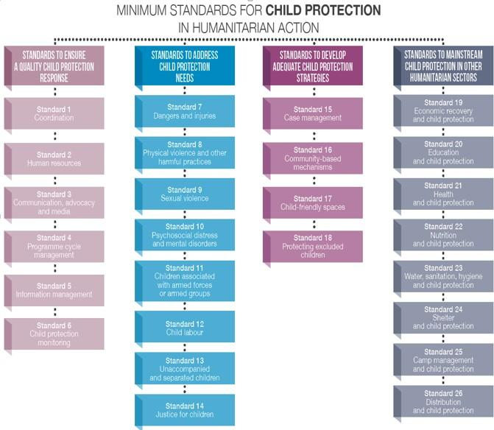

Annex 3: Methodology for the Formulation of Lessons Learnt
A | Description of conditions, causes or factors
Link it to a verb in past tense that introduces a relationship between these conditions and a consequence, result or effect: Explain, lead to, generate, have the effect of, influence, allow, facilitate, cause, hinder, be key to, be necessary, etc.
Description of the result, consequence, or effect (positive or negative).
B | Description of a final situation, result or consequence
+ Link it to a verb in past tense that introduces a relationship between this final condition and some conditions or causes: Come from, resulting from, be explained by, depend on, be due to, be the consequence of, require, etc.
+ Description of conditions or causes
C | Description of corrective action
+ Link it to a verb that introduces a cause-and-effect relationship with "would have": It would have made it possible, it would have strengthened, it would have improved, etc.
+ Description of the desired "ideal" situation

Annex 4: Qualitative instruments
Instrument 1: Question guide for in-depth interviews with adult male beneficiaries.
Dear sir_______, Good morning/ afternoon:
My name is ________ and I’m part of the team that is evaluating the Multipurpose Cash Assistance project for Vulnerable Venezuelan Citizens in Peru implemented by Save the Children. The objective of this brief interview is to know your experience with the project and collect your opinions about this process. The interview lasts 45 minutes, is anonymous and confidential, that is, we will not reveal your name or any other information that allows to identify the interviewee. Your participation is voluntary, you can leave the interview at any time and/or decide not to answer any of the questions you do not want. If you have any other question, please send your question or comment to quejasysugerencias.pe@savethechildren.org.
Do you agree to continue?
Yes (continue)
No (stop interview)
Let's start by talking about your experience since your arrival in Peru
- Can you tell me when did you arrive to Peru? How was your trip? Enquire into each phase: arrival to Peru, transit, settlement, departure.
- Can you describe with whom you arrived to Peru? Who do you live with?
- How did you organize? Who has the productive work? Who takes care of the house (cleaning, food)? Who takes care of the children?
- The project included a cash transfer for transit and lodging. While you were in transit in ______, did you receive support from the project? What type of support did you receive? Was it useful?
- When you settled in _________, did you receive support from the project? How long did it take you to receive the support after settling in that city? What type of support did you receive? Was it useful?
- How have you used the cash transfers you received?
- Tell me, how did you settle in your current address? How did you find it? How was the settling-in process in the new house?
- Have you and your family improved your living conditions due to the cash transfer? In what way? If the answer is No: Why do you think so?
- The project distributed information on nutritional practices. Did you receive this information? What do you remember? Was that information useful? Have you and your family improved your nutritional practices? In what way? If the answer is No: Why do you think so?

Let's talk about your family members
IN CASE THERE ARE CHILDREN AT HOME AND YOU ARE THE PRIMARY CAREGIVER
- Between 0 - 5 months, how did you feed the child(ren)? Why did you choose that diet?
- Between 6 months and 2 years, how did you feed the child(ren)? Why did you choose that diet?
- Has the migration process affected the child(ren) at home? How?
- If the answer is Yes: In particular, have the child(ren) demonstrated any type of behavioural problem during the migration process? (e.g. insomnia, aggressiveness, impulsiveness, mood swings, insecurity, lack of appetite, little desire to play, self-aggression or risk exposure)? Can you tell me more about it?
- One of the Project activities was a friendly space for children. Have your child(ren) used that friendly space for children? Can you tell me what did you think of having that space? Do you think that space has helped the child(ren) to cope with this experience? In what way?
- Do you think that friendly space has had an effect on the emotional health of the child(ren)? In what way? Why do you think so?
- Are there older people or people with special needs at home? Have the project activities (cash transfers, psychosocial support) improved the conditions of these members at home? In what way? If the answer is No: Why do you think so?
Now let’s talk about your opinion about the project
- Do you think this project has helped you? In what way? If the answer is No: Why do you think so?
- What impact has this project had on your migration situation? Why?
- Do you consider that humanitarian response organizations worked in a coordinated manner? In what way?
- What recommendations can you make to improve the Project?
- What do you think was the best part of the Project? Why?
- During the project, was the intervention team who assisted you composed of women and men? What do you think about the task distribution?
- Are you currently using the information or resources you obtained thanks to the project? In what way?
- Do you think that Peruvians in the community where you settled are better prepared to receive Venezuelan migrants? Why?
- Do you feel integrated to your new community at present? In what way? If the answer is No: Why do you think so? In your opinion, are there differences between men and women when integrating into a society in Peru? Which ones?
- Do you think the COVID-19 crisis has affected your life and the life of your family? In what way?

Instrument 2: Question guide for in-depth interviews with adult female beneficiaries.
Dear madam_______, Good morning/ afternoon:
My name is ________ and I’m part of the team that is evaluating the Multipurpose Cash Assistance project for Vulnerable Venezuelan Citizens in Peru implemented by Save the Children. The objective of this brief interview is to know your experience with the project and to collect your opinions about this process. The interview lasts 45 minutes, is anonymous and confidential, that is, we will not reveal your name or any other information that allows to identify the interviewee. Your participation is voluntary, you can leave the interview at any time and/or decide not to answer any of the questions you do not want. If you have any other question, please send your question or comment to quejasysugerencias.pe@savethechildren.org.
Do you agree to continue?
Yes (continue)
No (stop interview)
Let's start by talking about your experience since your arrival to Peru
- Can you tell me when did you arrive to Peru? How was your trip? Enquire into each phase: arrival to Peru, transit, settlement, departure.
- Can you describe with whom you arrived to Peru? Who do you live with?
- How did you organize? Who has the productive work? Who takes care of the house (cleaning, food)? Who takes care of the children?
- The project included a cash transfer for transit and lodging. While you were in transit in ______, did you receive support from the project? What type of support did you receive? Was it useful?
- When you settled in _________, did you receive support from the project? How long did it take you to receive the support after settling in that city? What type of support did you receive? Was it useful?

- How have you used the cash transfers you received?
- Tell me, how did you settle in your current address? How did you find it? How was the settling-in process in the new house?
- Have you and your family improved your living conditions due to the cash transfer? In what way? If the answer is No: Why do you think so?
- The project distributed information on nutritional practices. Did you receive this information? What do you remember? Was that information useful? Have you and your family improved your nutritional practices? In what way? If the answer is No: Why do you think so?
- Have you received psychosocial support from the project? What was your experience?
- Do you think the psychosocial support has had any effect on your wellbeing and ability to cope with difficulties?
- During the migration process, have you face conflicts or stress at home? Can you tell me about it?
- QUESTIONS IF YOU WERE PREGNANT OR HAVE BEEN PREGNANT What was/is your diet during pregnancy? Why did you choose that diet?

Let's talk about your family members
IN CASE THERE ARE CHILDREN AT HOME AND YOU ARE THE PRIMARY CAREGIVER
- Between 0 - 5 months, how did you feed the child(ren)? Why did you choose that diet?
- Have you heard of exclusive breastfeeding? Did you choose this option? What were your reasons?
- Between 6 months and 2 years, how did you feed the child(ren)? Why did you choose that diet?
- Has the migration process affected the child(ren) at home? How?
- If the answer is Yes: In particular, have the child(ren) demonstrated any type of behavioural problem during the migration process? (e.g. insomnia, aggressiveness, impulsiveness, mood swings, insecurity, lack of appetite, little desire to play, self-aggression or risk exposure)? Can you tell me more about it?
- One of the Project activities was a friendly space for children. Have your child(ren) used that friendly space for children? Can you tell me what did you think of having that space? Do you think that space has helped the child(ren) to cope with this experience? In what way?
- Do you think that friendly space has had an effect on the emotional health of the child(ren)? In what way? Why do you think so?
- Are there older people or people with special needs at home? Have the project activities (cash transfers, psychosocial support) improved the conditions of these members at home? In what way? If the answer is No: Why do you think so?

Now let’s talk about your opinion about the project
- Do you think this project has helped you? In what way? If the answer is No: Why do you think so?
- What impact has this project had on your migration situation? Why?
- Do you consider that humanitarian response organizations worked in a coordinated manner? In what way?
- What recommendations can you make to improve the Project?
- What do you think was the best part of the Project? Why?
- During the project, was the intervention team who assisted you composed of women and men? What do you think about the task distribution?
- Are you currently using the information or resources you obtained thanks to the project? In what way?
- Do you think that the members of the community where you settled are better prepared to receive Venezuelan migrants? Why?
- Do you feel integrated to your new community at present? In what way? If the answer is No: Why do you think so? In your opinion, are there differences between men and women when integrating into a society in Peru? Which ones?
- Do you think the COVID-19 crisis has affected your life and the life of your family? In what way?

Instrument 3: Question guide for in-depth interviews with the Project personnel.
Dear Mr./Ms._______, Good morning/ afternoon:
My name is ________ and I’m part of the team that is evaluating the Multipurpose Cash Assistance project for Vulnerable Venezuelan Citizens in Peru implemented by Save the Children. The objective of this brief interview is to know your experience with the project and collect your opinions about the design and implementation. The interview lasts 60 minutes, is anonymous and confidential, that is, we will not reveal your name or any other information that allows to identify the interviewee.
Do you agree to continue?
Yes (continue)
No (stop interview)
- Did you have field experience assisting Venezuelan migrants? In your experience, can you describe the most common problems of migrants?
- What was the profile of the families?
- What sector/sub-sector of the project did you work in? Can you describe your job?
- Did your sector/subsector achieve the expected results? In what way? Why do you think so?
- During the interventions of your sector/sub-sector, did the interventions reach target groups and individuals within the areas of intervention (groups in transit and settlement groups, pregnant and lactating women, older adults, people with disabilities, children participating in friendly spaces and children under 2 years)?
- Do you think the project equally benefited men and women? Why?
- What are the intended and unintended effects of the project on women and men?
- FOR REGIONAL COORDINATORS ONLY: How did the inter-agency coordination work? Did you think it was efficient? Why? How useful did you find? Why?
- How was the information management carried out? Did you think it was efficient? Why? How useful did you find? Why?
- ONLY FOR REGIONAL COORDINATORS: Thanks to the project, do you think the coordination among the different stakeholders related to the humanitarian response has improved? In what way? If the answer is No: Why do you think so?
- Do you consider that the project adequately met the needs of the beneficiaries? What aspects would you improve regarding the project design?
- Do you consider that the selection and registry system was efficient? Why? What aspects would you have improved regarding the targeting?
- According to the project implementation, do you consider that the activities were carried out as planned? What problems arose during the implementation? What aspects would you improve in the implementation?
- What good practices do you think was achieved with the project?
- Can you tell me how the project was managed? How were (economic, material, human) resources organized? How efficient did you find the project management?
- The project also had a number of information registration systems of beneficiaries, inputs, products and results. How were these registrations handled? How were they updated/verified? Did you find the information accessible, accurate and useful?
- The project also had several processes: What did you think about...?
.... the information about access to shelters?
.... the registry of beneficiaries in transit?
... the distribution of cash for transit?
.... the registry of beneficiaries in settlement?
... the distribution of cash for settlement?
... the friendly space?
... the psychosocial support services?
... the nutrition counselling?
.... the information for the settlement?
... the integration activities?
- How efficient has the use of financial resources been in obtaining the results?
- Do you consider that, thanks to the project, girls, adolescents and women, and pro have been protected and provided with safe conditions during the migration process? In what way? Do you consider, that thanks to the project, female migrants have the same opportunities to settle and integrate as male migrants? Why?
- Do you consider that the project has managed to safeguard children from any risk? In what way?
- Did staff supervision achieve the results? In what way? If the answer is No: How could this aspect be improved?
- What conflicts in project management arose throughout the implementation? How were these conflicts managed?
- How were the implementation teams organized and what was their gender distribution?
- What child protection issues were identified? How were child protection issues addressed?
- Do you think the project equally benefited men and women? Why? What gender gaps were identified? How were gender inequalities addressed?
- About the amount of inputs that were used for the activities, were they sufficient? What did you think of the quality?
- How do the outputs/products contribute to the organization’s objectives?
- How is the sustainability of the project being ensured?
- Were there any unexpected effects/unforeseen changes?
- To what extent has the COVID-19 crisis affected the beneficiaries of the project? Are all equally affected?

Instrument 4: Question guide for in-depth interviews with partners.
Dear Mr./Ms._______, Good morning/ afternoon:
My name is ________ and I’m part of the team that is evaluating the Multipurpose Cash Assistance project for Vulnerable Venezuelan Citizens in Peru implemented by Save the Children. The objective of this brief interview is to know your experience with the project and collect your opinions about the joint and coordinated work that was done. The interview lasts 60 minutes, is anonymous and confidential, that is, we will not reveal your name or any other information that allows to identify the interviewee.
Do you agree to continue?
Yes (continue)
No (stop interview)

- Can you describe what the common problems of the migrants you worked with were?
- How were the groups of migrants formed? How were they organized?
- How did inter-agencies coordination work? Did you think it was efficient? Why? How useful did you find? Why?
- About the handling of information, several agencies used an online platform with beneficiary data to avoid duplication. What did you think of this tool?
- How was the information management carried out? Did you think it was efficient? Why? How useful did you find? Why?
- Do you think the project equally benefited men and women? Why? What gender gaps were identified? How were gender inequalities addressed?

Annex 5: Testing of differences between databases and cohort
Welsh test output

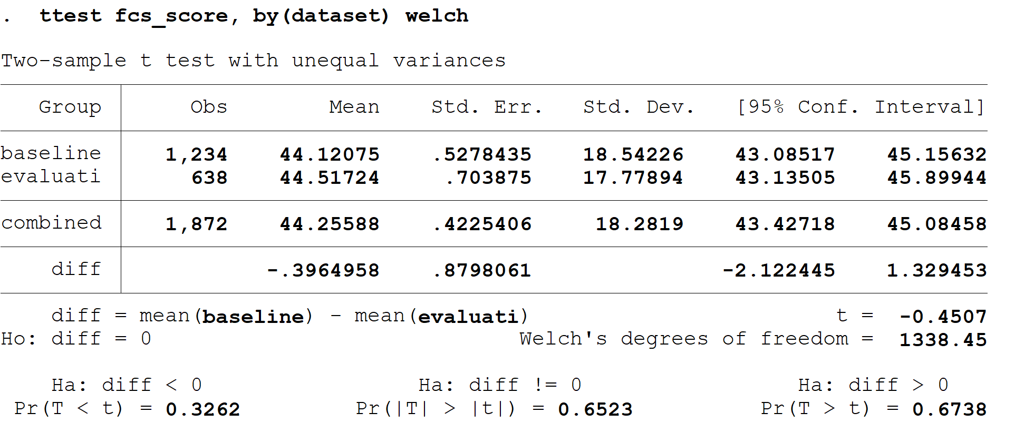
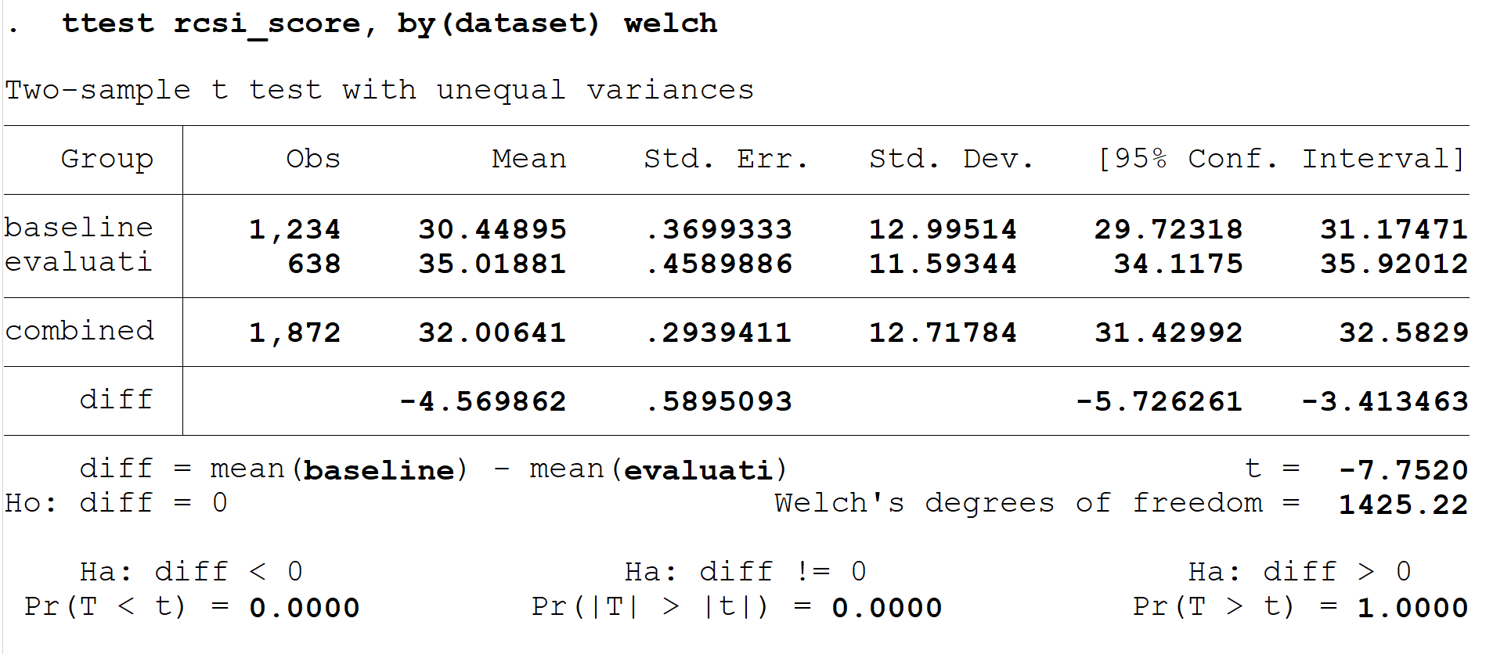

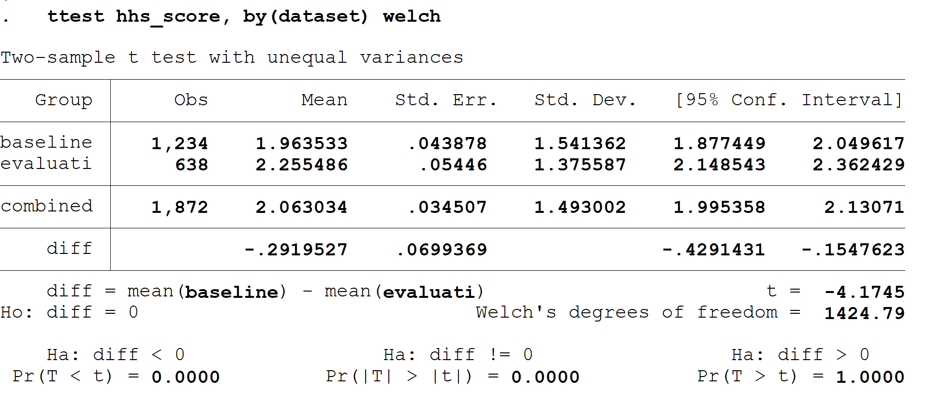

Test for difference in means between gender variable (male and female) for each of the main indicators

Fcs_score
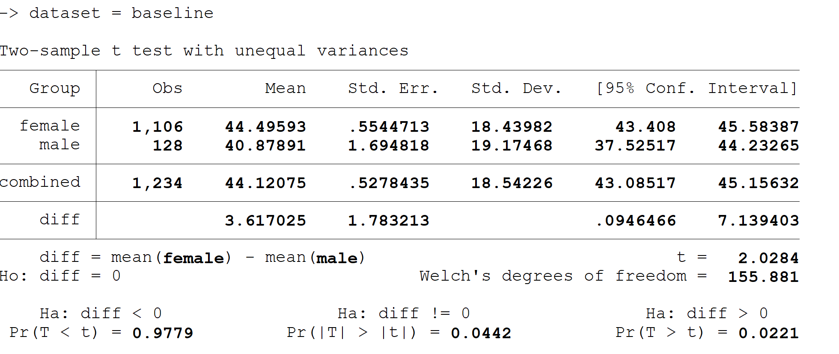

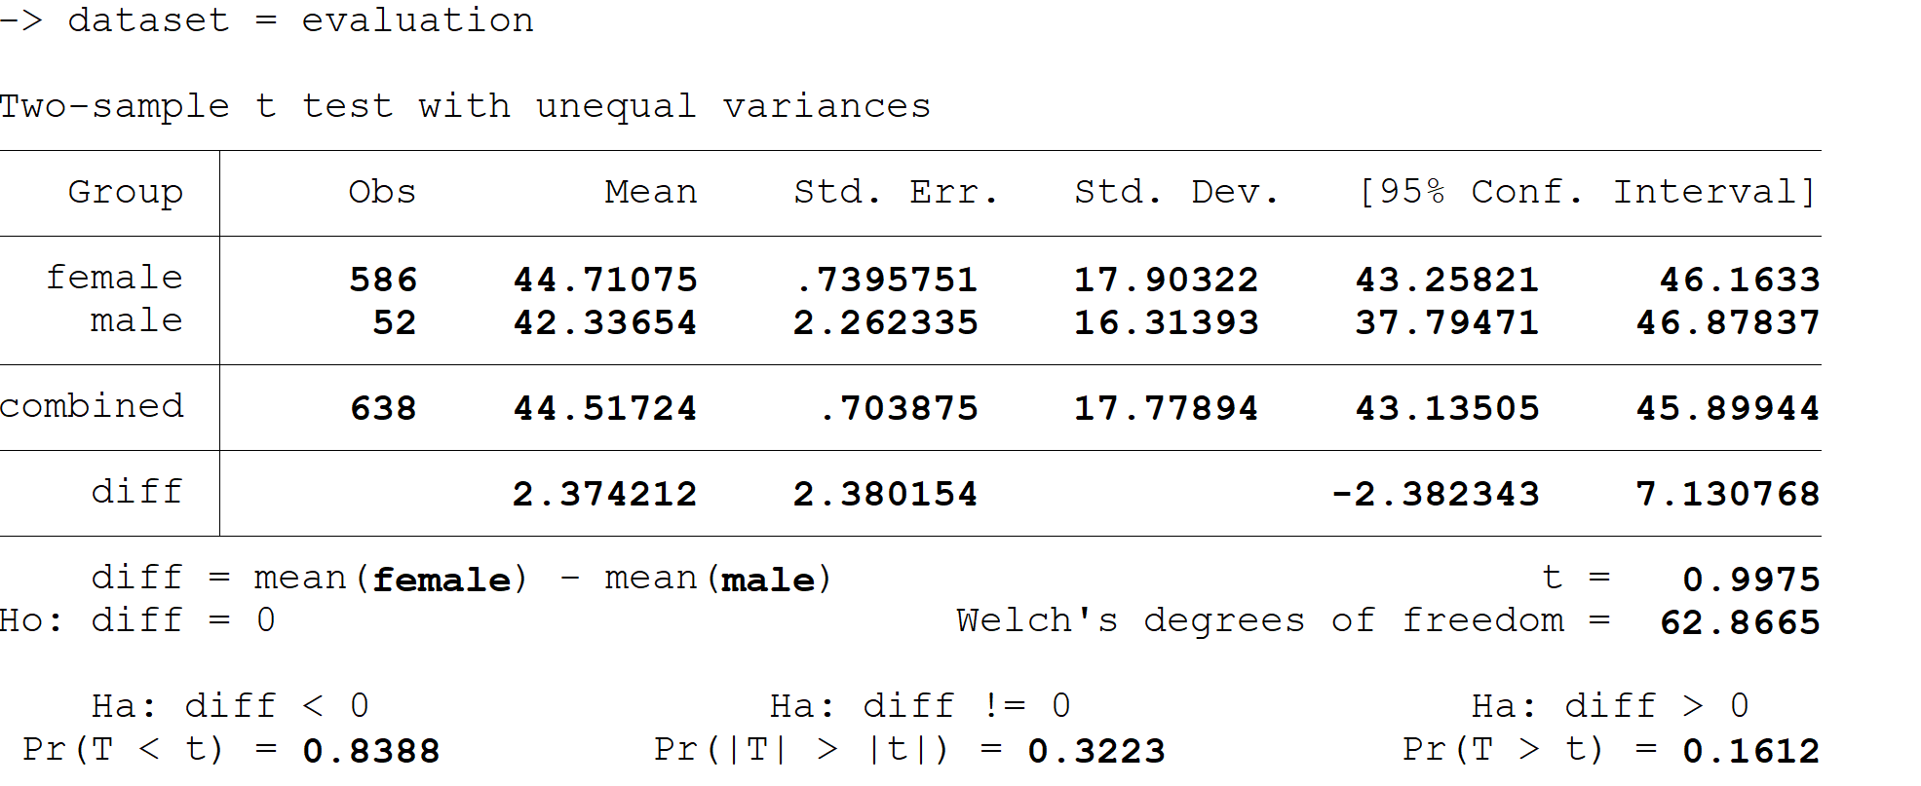

Rcsi_score
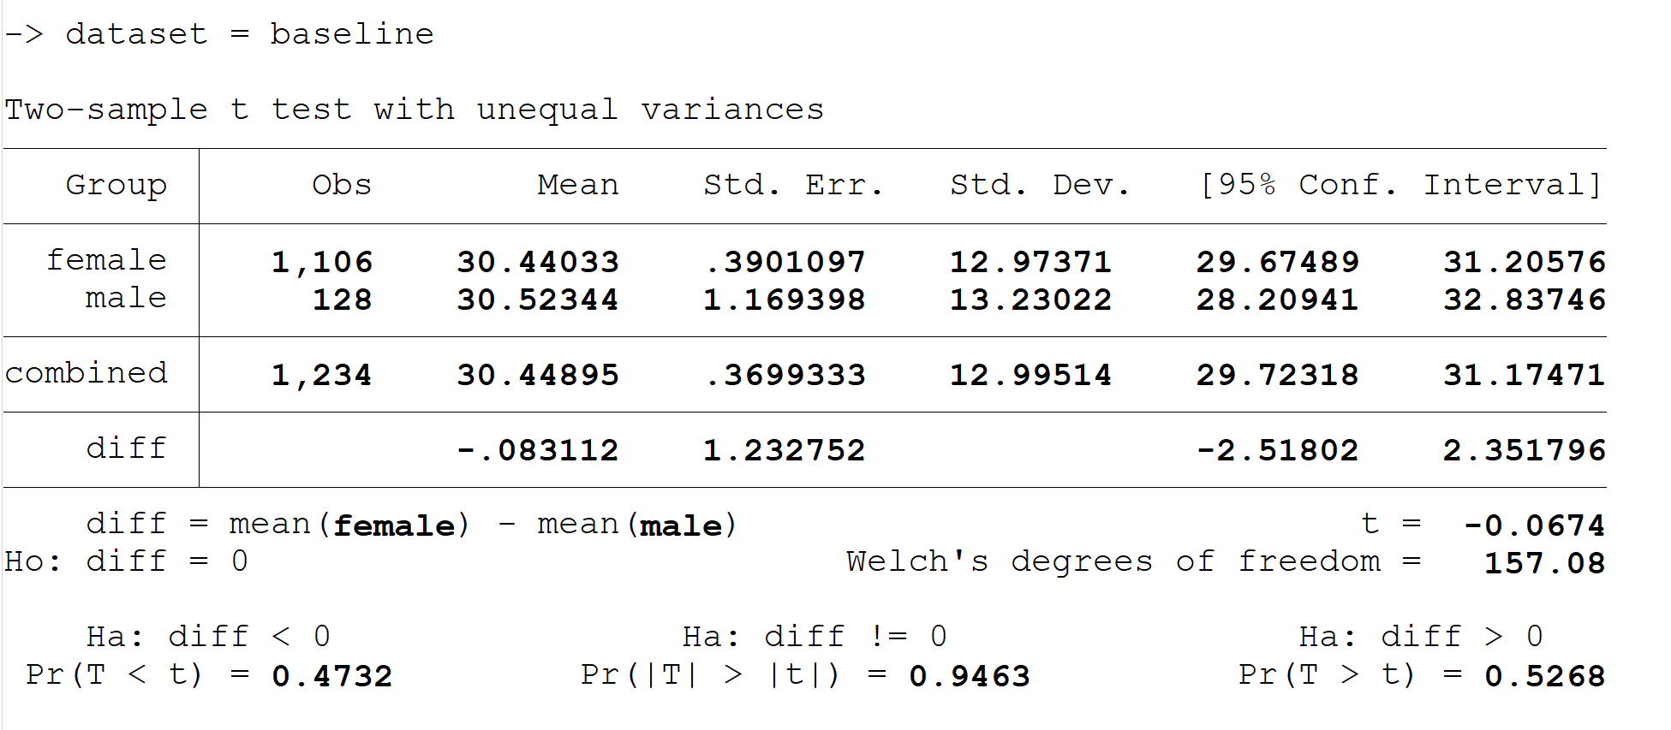

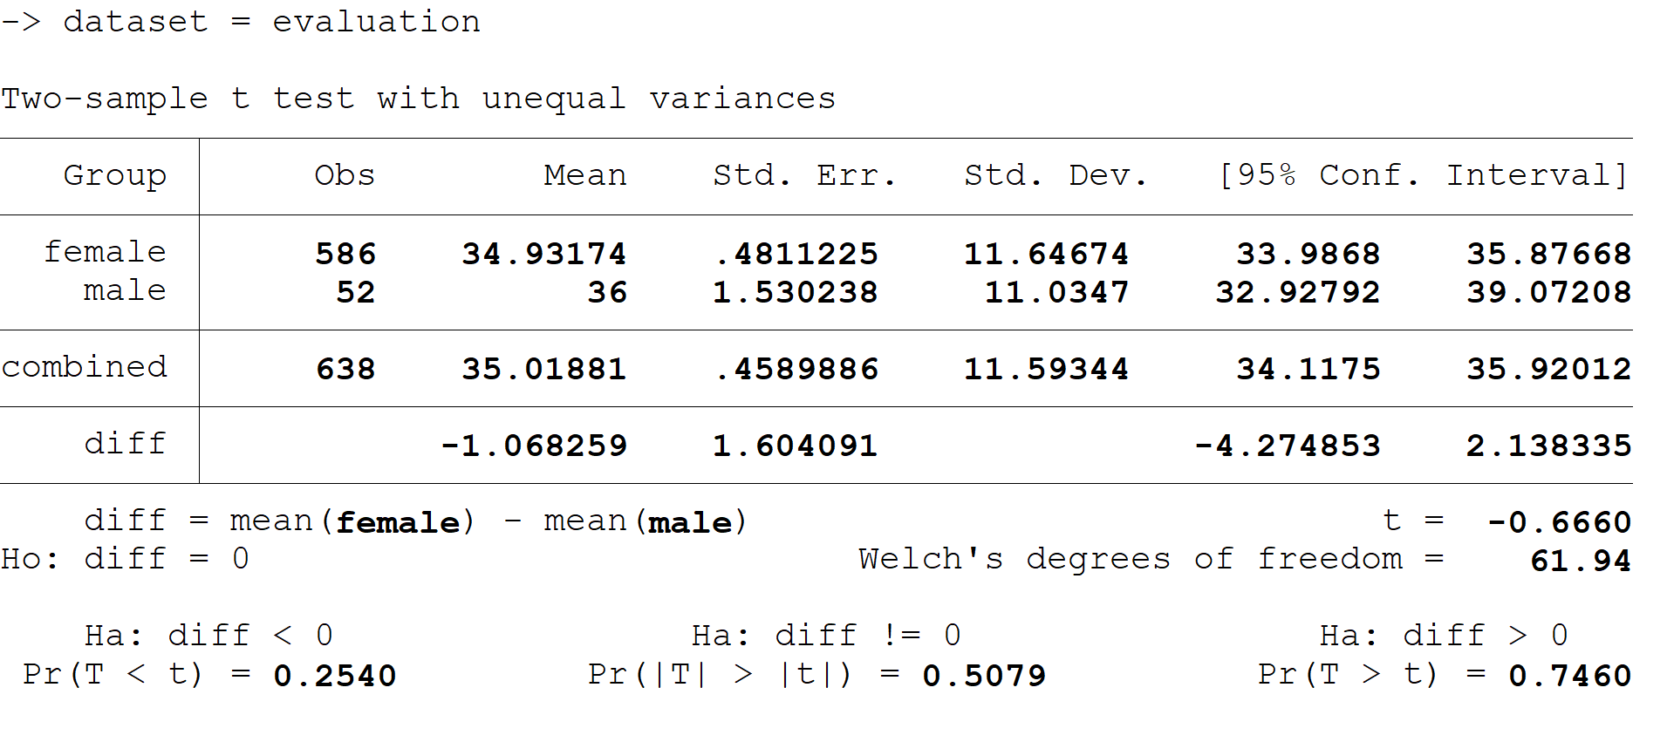
Hh_score

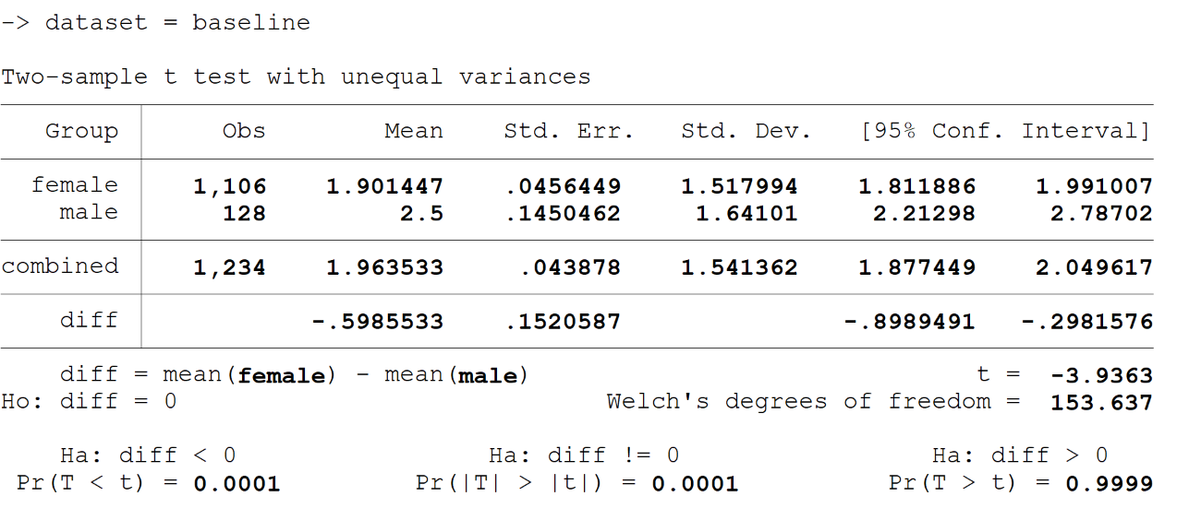

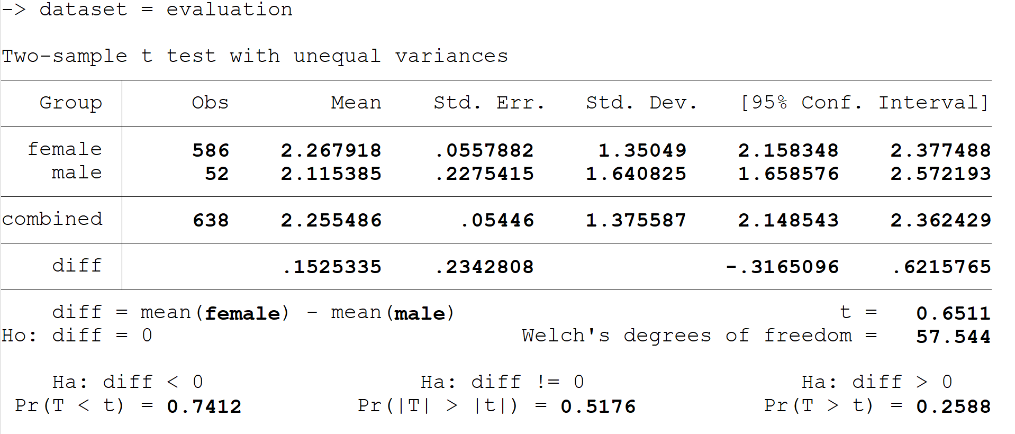

Inputs are the raw materials that provide a basis for security and justice programmes. Inputs may include money, technical expertise, relationships and staff. Products: these are tangible and intangible and result from the project activities. Outcomes represent the benefits that a project or intervention is designed to offer. Finally, impacts are the top-level strategic objectives.
The Welsh test is recommended instead of Student t-test to find significant differences between group averages with different sample sizes that may have different variances.
IPC 3 - Households either have food consumption gaps that are reflected by high or above-usual acute malnutrition; or are marginally able to meet minimum food needs but only by depleting essential livelihood assets or through crisis-coping strategies. IPC 4 - Households either have large food consumption gaps, which are reflected in very high acute malnutrition and excess mortality; or are able to mitigate large food consumption gaps but only by employing emergency livelihood strategies and asset liquidation. IPC 5 - Households have an extreme lack of food and/or other basic needs even after full employment of coping strategies. Starvation, death, destitution, and extremely critical acute malnutrition levels are evident.
IPC 2 - Households have minimally adequate food consumption but are unable to afford some essential non-food expenditures without engaging in stress-coping strategies.
IPC 1 - Households are able to meet essential food and non-food needs without engaging in atypical and unsustainable strategies to access food and income.
Although the original design of the project only provided up to 3 transfers for settlement households, given the COVID-19 pandemic and its negative economic impact, SC provided a COVID/emergency top-up to as many households as possible in April.
It is important to note, however, that the overall sample for children under two at endline was about half that at baseline. Therefore, the results at endline may not be fully representative of the total beneficiary population.
Austrian Development Cooperation (2009). Guidelines for Project and Programme Evaluations. Final Draft (July 2009). Retrieved from: https://www.oecd.org/development/evaluation/dcdndep/47069197.pdf
UNHCR (2019). The 2019 Minimum Standards for Child Protection in Humanitarian Action. Retrieved from: https://emergency.unhcr.org/entry/80339/minimum-standards-for-child-protection-in-humanitarian-action
https://blogs.iadb.org/conocimiento-abierto/es/como-documentar-lecciones-aprendidas/

